**Bedford Borough Safeguarding Children Board**

**Strategic Plan 2021 - 2023**

**BBSCB has agreed the following themes to direct its work for 2021 – 2023:**

**Safeguarding children and young people . . . . .**

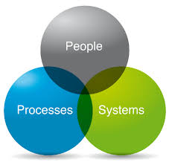

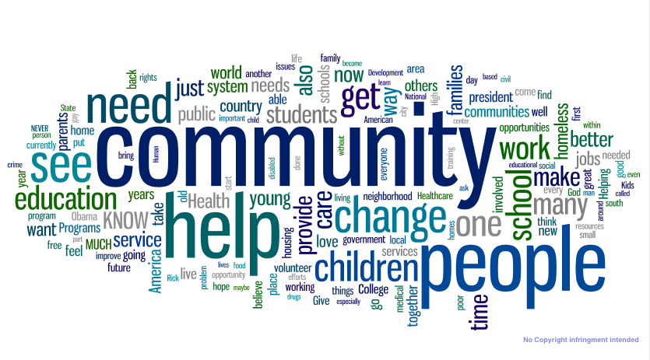 **In the home In the community** **Through effective systems and processes**

**Neglect**

**Early Help**

**Digital Safeguarding**

**Domestic Abuse**

**Mental Health and Emotional Wellbeing**

**Transition - children’s to adults’ services**

**Policy & procedures**

**Thresholds to services**

**Information sharing**

**Audit, Reviews, Learning, Development & Training**

**Independent scrutiny**

**Contextual safeguarding Knife Crime & Gangs**

**Exploitation (Child Sexual & Criminal Exploitation, Missing)**

Some of these will be jointly across pan Bedfordshire and one area will focus on a place-based approach in a specific area of Bedford Borough.

**Golden threads throughout this plan**

**Links to other Partnerships & their action plans & strategies which are developed, in place & monitored**

**The voice & engagement of frontline practitioners**

**Performance & practice monitoring and analysis**

**Learning from practice reviews and multi-agency**

**& single agency audits**

**Multi- agency and single agency training delivery and evaluation**

**Lived experience**

**& voice of children and young people**

To fulfil the Bedford Borough Safeguarding Children Board’s Multi Agency Safeguarding Arrangements the following will be presented/developed/commissioned.

**Assurance Reports;**

**Voice and Lived experience children and young people, Safeguarding in Education, Disabled Children and young people, Looked after Children, Child Exploitation and Domestic Abuse.**

**Annual Reports;**

**Authority Designated Officer (LADO), Multi Agency Risk Assessment Conference (MARAC) and Child Death Overview Panel (CDOP).**