Bedford Borough Council’s V10
Supporting Families Outcome Plan

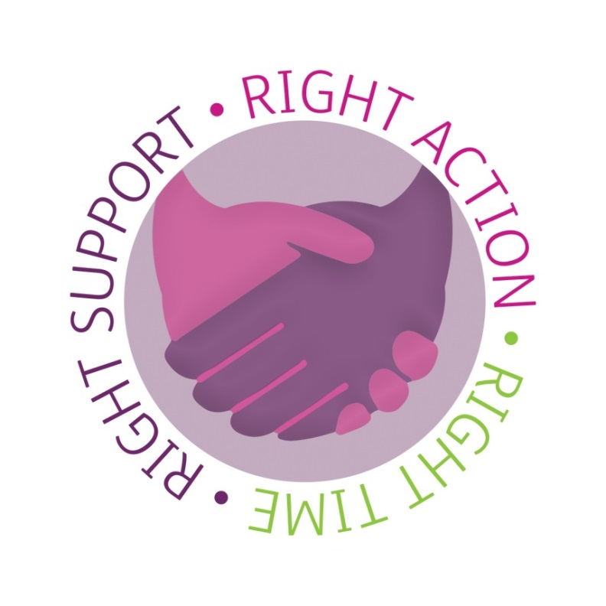

Principles of the Supporting Families Programme
- To be eligible for the Supporting Families Programme, a family member must have at least two of the indicators (criteria) from separate headline problems in the outcomes plan e.g. one from Education and one from Health. If a family member is not living in the family home, they will only ever be counted as one of the two criteria (even if they hit multiple criteria from different headlines).

- All Indicators selected must have the outcomes achieved in order for a Payment-by-result (PBR) to be achieved . In most instances you will have 3 possible outcomes that you can focus towards. Outcome 1, outcome 2 and outcome 3, which derives from the Family Star (also known as the Outcomes Star).

All school-aged children MUST have 90% (locally set target) attendance over 3 consecutive academic terms, immediately preceding a SF claim. For the purpose of Bedford’s SF programme, authorised absences can be counted as present marks to increase attendance rates to 90% or above to qualify for a SF claim.

- SF claims can also be made where a child makes a transition from home schooling to mainstream or special school environment.

- Working with complex cases in which the child’s attendance is e.g. under 40% and we improve it by at least a 40 % points (80%) , sustained for 3 consecutive terms, will quality for a SF claim. We must ensure families have not regressed in other areas of the Outcome Plan and all TAF plans are fully up to date and actions completed.

- 3A on the Bedford Outcome Plan is counted as an individual headline (child in need) , therefore 3A plus another headline from another section will be sufficient for the family to be included in the SF Programme e.g. 3A, 5A.

Headline Problem: Parents and Children Involved in Crime or Anti-Social Behaviour
Strategic Goal: Reduce the number of families involved in crime and anti-social behaviour.
Ref. | Indicator (Criteria) | Outcome 1 | Outcome 2 | Outcome 3  (Outcome Star) | Data source
1A | A child or Young person (aged 10 or above and under 19 years of age) who has committed a proven offence in the previous 12 months, e.g. carrying a weapon e.g. knife | No further offending for 26 weeks from case closure | Child / Young person engages in an intervention (Project 180 or another intervention and does not reoffend for 26 weeks from case closure. |  | Bedford YOS Register  Professional working with the family.  Family Plan Notes
1B | An adult who has committed a proven offence in the previous 12 months. | Family is supported and no further offending for 26 weeks from case closure |  |  | Police Data shows no incidents (e.g. monthly Police data feed to council)  Family Plan Notes
1C | A child or adult who has been involved (formally or informally) with Gangs, ASB or County Lines in the last 12 months | No further ASB by the child or adult for 26 weeks from case closure. | Reaching a minimum of 7 on Family Star Plus  (Boundaries & Behaviours) |  | ASB team  Adolescent Response Team  Lead Professional / family plan notes  Police Data shows no incidents Family Plan Notes
1D | Adult or Young Person identified by a professional because of their potential crime/offending behaviour is of concern | A parent has completed protective behaviours support and no re referral for 26 weeks from case closure. | Reaching a minimum of 7 on Family Star Plus (Boundaries & Behaviours) |  | Family Plan Notes  Lead Professional  Parenting Data shows no incidents  (e.g. monthly Police data feed to council)
1E | Adult prisoner (or YP) who is less than 12 months from his/her release, with parenting responsibilities. | The individual has engaged with family support with no re offending for at least 26 weeks from point of case closure. |  |  | Probation  Lead Professional  Parenting Data  1:1 intervention pack / TAF notes
1F | An adult currently serving a community order or suspended sentence who has parenting responsibilities. | The individual has engaged and completed the appropriate evidence based parenting service on offer with no re referral for 26 weeks from point of case closure. |  |  | Probation  Lead Professional Parenting Data / TAF notes
1G | Adults and children at risk of radicalisation | Individual engages with Prevent Training and reoccurrence of incidents for at least 26 weeks. |  |  | Professional notes /family plans / Police Data shows no reoffending.

Headline Problem: Children Who Have Not Been Attending School Regularly
Strategic Goal: Improve the attendance of school-age children within families and promote positive behaviour.

Ref. | Indicator (Criteria) | Outcome 1 | Outcome 2 | Outcome 3  (Outcome star) | Data source
2A | A child who is persistently absent (i.e. less than 90% attendance) from school (with EHCP to 25 YOA) and makes significant progress towards improving their school attendance to at least 90%.(exception outcome 2) | Children have attended minimum 90%  of possible sessions over 3 consecutive terms.  (when measuring 90 % attendance we have discretion to discount authorised absences when calculating overall attendance ) | A child with attendance under 40% has increased their attendance by 40 % points, to include authorised absences |  | Local authority statutory school attendance census returns  Or  Attendance Certificate / TAF notes
2B | Child receiving at least 3 fixed term exclusions in the last 3 consecutive terms. | Reduction to 1 incident of fixed term exclusion over 26 week period | Reaching a minimum of 7 on Family Star Plus  (Education and learning) |  | Fixed term exclusion register/ Lead Professional , family plan notes
2C | Child permanently excluded from school in the last 3 consecutive terms. | Child is settled in and engaging with an appropriate education programme for at least 26 weeks from case closure. | Reaching a minimum of 7 on Family Star Plus: (Education and learning) |  | Permanent exclusion register/ Lead Professional notes
2D | Child attending alternative education provision for medical or behavioural problems. | Child is settled in and engaging with an appropriate education programme for at least 26 weeks from point of case closure. | Reaching a minimum of 7 on Family Star Plus  (Education and learning) |  | Lead Professional notes
2E | Child who is not registered with a school, or educated otherwise NEET | Child is settled in and engaging with appropriate education programme for  over 26 weeks from point of case closure.  For children being home educated, evidence from home visits details an appropriate education taking place at home or child is returned to mainstream schooling. | A young person with an attendance level under 90% who then engages in Employment, Education in Year 12 or an apprenticeship for at least 12 weeks. | Reaching a minimum of 7 on Family Star Plus, (Education and learning) | Lead Professional / Family Plan Notes
2F | information received from parent or professional or member of public that  a child who is residing in Borough is neither registered with a school , nor being educated in an alternative setting, | Child is settled in and engaging with an appropriate educational programme for three academic terms with attendance at 90% or above. |  |  | Family Plan Notes/ case notes/ attendance register data

Headline Problem: Children Who Need Help
Strategic Goal: Reduce the number of children known to services, including those above/below the thresholds for statutory intervention & Early Help.
Ref. | Indicator (Criteria) | Outcome 1 | Outcome 2 | Outcome 3  (Outcome star) | Data source
3A | Child who has been identified or assessed as needing Early Help Intervention. | Successful closure of the team around the family with no re-referral for 26 weeks. |  |  | Professional working with family / Family Plan Notes
3B | Child who has been identified as having behavioural issues related to routines and/or Boundaries. | The family and/or supporting professionals report that the behaviour has significantly improved for at least 26 weeks. | The individual has engaged & completed the appropriate evidence based parenting service on offer. | Reaching a minimum of 7 on Family Star Plus  (Boundaries & Behaviours) | Professional working with family / Family Plan Notes
3C | A case previously or currently involved with social care eg CiN or Child Protection (sec 17 CA 1989 or Sec 47 CA 1989), which requires joint work with Early Help or has been stepped down to Early Help. | Successful engagement after being stepped down to TAF, with no repeat referrals to Early Help for a further 26 weeks from case closure. | Following step down from social care the individual has engaged & completed the appropriate evidence based parenting offer, with no re referral for a period of 26 weeks. |  | Professional working with family / Family Plan Notes
3D | Child has been identified as being subject to (or at risk of) neglect. | A Graded care profile score of 1-3 on all areas. | Neglect (or risk of neglect)  is not a concern to the lead professional at the point of closure, with no re referral for 26 weeks. |  | GCP2/ Lead Professional  / Family Plan Notes
3E | Child who has failed to take up or disengaged from the 2, 3 & 4 Nursery Education Funding. | Family is accessing Early Years Entitlement and attending regularly for a minimum of 26 weeks. |  |  | Professional working with family/ Family Plan Notes
3F | A child/young person has been identified as being at risk of sexual exploitation. | No CSE risk over a period of 26 weeks. | A parent has completed the protective behaviours programme. | Reaching a minimum of 7 on Family Star | Professional working with family Plan Notes
3G | Child does not attend a 2.0 years integrated review or there are concerns raised from the review. | Family engaging with appropriate Early Years Early Help services and is sustained for 26 weeks without re referral. | Reaching a minimum of 7 on Family Star Plus  (Physical Health) |  | Professional working with family/ Family Plan Notes
3H | Families where a expecting young mum aged under 25 or / teen mum is pregnant, or has given birth. | Mother engages with the Teen Parents Pathway, Or Parents as First Teachers to meet her and baby’s basic needs. | Mother engages with appropriate services for a period of 12 weeks and is not re-referred to statutory services for a period of 26 weeks from case closure | Reaching a minimum of 7 on Family Star Plus  OR Infant Mental Health IAPT therapy, OR VIPP, Video Interaction for positive parenting | Professional working with family / Family Plan Notes
3I | A child who has not received a good level of development at age five or under. Information received from Early Years, Parent , or professional | Early Help Assessment completed and TAF held leading to child achieving basic needs and initial issues resolved as detailed by TAF progress. |  |  | Professional working with family / Family Plan Notes

Headline Problem: Adults Out of Work or at Risk of Financial Exclusion & Young People at Risk of Worklessness
Strategic Goal: Improve the economic wellbeing of families through working-age adults entering sustained employment.
Ref. | Indicator (Criteria) | Outcome 1 | Outcome 2 | Outcome 3  (Outcome star) | Data source
4A | Adult in receipt of out of work benefits (or) adult claiming Universal Credit and subject to work related conditions. | An Adult within the family has moved off out-of-work benefits into continuous employment  Eg 1 From ESA to sustained work for 13 weeks  Eg 2 From JSA to sustained work for 26 weeks | 2a, An adult in the family is taking recognised steps to prepare for work (see annex B).  2 b, Adult in the family completes a recognised qualification or training course leading them closer to the labour market  2c, Or Adult in the family is digitally enabled, has a suitable structured CV, is registered with Bedford Job’s hub & or Job Centre and has an appropriate email account setup. |  | TFEA / Lead Professional notes /  Benefits Data  ADMS  Bedford Job Centre  Bedford jobs Hub  Evidenced by client / employer correspondence
4B | Child about to leave school with few or no qualifications and no planned education, training or employment (Pre-NEET). | Young person makes ‘job ready’ progress by;  - Enrolled in high/further education or apprenticeship 26 weeks)  - Completes a 12 week course  - Formal volunteering ( 8 weeks) | Young person in the family is digitally enabled, has a suitable structured CV, is registered with Bedford Job’s hub & or Job Centre and has an appropriate email account setup. |  | TFEA  ADMS  Bedford jobs Centre/ Hub  Lead Professional notes
4C | A young person aged 16-18yrs within the family who is not in education, employment or training (NEET), Information from young person, school , or local authority census or other data | The young person aged 16-18yrs within the family are now in Education, Employment or Training. (Sustained for 26 weeks). | Reaching a minimum of 7 on Family Star Plus  (Education and Learning) |  | Professional working with family/ NEET register
4D | Parents and families referred by professionals as being at significant risk of financial exclusion or in financial difficulties. | Families are engaging with specialist services provided and are seeking solutions to their financial issues. | A budget plan is in place with the family (12 weeks) or no longer at risk of eviction  (26 weeks). | Reaching a minimum of 7 on Family Star Plus  (Home and money) | Professional working with family / Family Plan Notes
4E | Family subject to unmanageable levels of household debt, risk of eviction, homelessness, financial exclusion or welfare reform or in rent arrears | Families are engaging with specialist services. Financial advice is accepted and the family are seeking solutions to their financial issues. | Clear evidence of the family paying down their debts e.g. a debt payment plan. | Reaching a minimum of 7 on Family Star Plus  (Home and money) | Professional working with family Plan Notes  /
4F | Families at risk of inadequate housing or homelessness. Information received from family, local authority housing department , landlord or professionals | Early Help Assessment completed with TAF and family are supported to be re-housed with no further housing evictions for 26 weeks. | Family are housed with relatives or friends and are on the housing waiting list OR are bidding on properties, |  | Professional working with family or family plan minutes / copy of tenancy

Headline Problem: Families Affected by Domestic Violence and Abuse
Strategic Goal: Reduce incidences of domestic violence and abuse within families.

Ref. | Indicator (Criteria) | Outcome 1 | Outcome 2 | Outcome 3  (Outcome star) | Data source
5A | Referral or information identifies a young person or adult at risk of experiencing domestic violence or abuse or is a perpetrator of domestic abuse | Domestic violence/abuse has ceased in the household for a minimum of 26 weeks. | The completion of a domestic abuse programme. | Young Person completes engages in a therapeutic intervention with no further issues reported over a 26 week period. | Professional working with family or family plan minutes
5B | Young person or adult known to local services as having perpetrated an incident of domestic violence or abuse in the last 12 Months. | The perpetrator has successfully completed a recognised rehabilitation programme and the Domestic /abuse / parental conflict has ceased for a minimum of 26 weeks. | The completion of an appropriate parenting programme ( eg who’s in charge). For young perpetrators,  reaching a minimum of 7 on Family Star Plus (Boundaries & Behaviours) Parental Conflict Support |  | Professional working with family / Family Plan Notes/ Support notes
5C | A child affected by Parental Conflict as detailed by parent , public or professional/s / or via assessment/s | Parent and child engages with an intervention to reduce parental conflict and no re referral for 26 weeks. | Family attend RELATE or another form of mediation or support sessions. | Family Star completed and reaches minimum of 7 | No re-referral for 26 weeks  / Family Plan Notes

Headline Problem: Parents and Children with a Range of Health Problem
Strategic Goal: Improve the health and wellbeing of families.
Ref. | Indicator (Criteria) | Outcome 1 | Outcome 2 | Outcome 3  (Outcome star) | Data source
6A | A parent or child with physical or mental health difficulties (including SEN or social, emotional and developmental needs). | The parent’s takes responsibility for managing their families’ specific health needs and are engaging with relevant services leading to case closure and no re referral for a period of 26 weeks . | At point of case closure family reaching a minimum of 7 on a Family Star tool. No re referral for 26 weeks from case closure. |  | Professional working with family / Family Plan Notes
6B | An adult with a drug or alcohol problem/s. | Adult engages in appropriate services and case is closed with no further referrals for 26 weeks. . | Reaching a minimum of 7 on Family Star Plus (Your well-being). |  | Professional working with Family / Family Plan Notes
6C | A Young Person with a drug or alcohol problem. Or mental Health issues | Young Person engages with appropriate mental health or drug or alcohol service and case is closed and no re referral for 26 weeks. | Reaching a minimum of 7 on Family Star Plus (Your well-being). |  | Professional working with the family. / Family Plan Notes
6D | Families who have not consistently engaged  with Universal Health Services.to resolve their health issues | The parent’s takes responsibility for managing their families’ specific health needs leading to case closure and no further referrals for 26 weeks. | Reaching a minimum of 7  on Family Star Plus  (Physical health) |  | Professional working with the family. / Family Plan Notes
6E | A child caring for an adult within the family (young carer) | Child or Adult engages with young carers and is receiving the appropriate levels of support  ( monitored for a minimum of 26 weeks). | Reaching a minimum of 7  on Family Star Plus  (Meeting emotional needs) |  | Professional working with the family. / Family Plan Notes

Benefit | Period of continuous employment
Job Seekers Allowance | 26 Weeks (out of the last 30 weeks)
Job Seekers Allowance (ex- Incapacity Benefit Claim) | 13 Consecutive Weeks
Employment Support Allowance
Income Support
Incapacity Benefit
Carer’s Allowance
Severe Disability Allowance

Annex A

Annex B
Summary of Outcome | Has at least 3 individual elements from list below qualifying for an outcome
The outcome involves the individual moving on from not being in education employment or training to a place where significant change has allowed them to sustain their move towards employment, education or training for a period of at least 13 weeks. | - Voluntary work (8 weeks)  - Completes a 8 week course (including employability course)  - Enrolled in high/further education or apprenticeship (at least 26 weeks )  - Work experience programme or course which removes a barrier to work for the individual for a period of at least 12 weeks.  - Up-to-date understanding of the Labour Market  - A completed up-to-date Curriculum Vitae  - Able to self-motivate towards employment and is able to job search without further support.  - Completes a IT course and is digitally enabled

Acronyms
ABC | Acceptable Behaviour Contract
ADMS | Automated Data Matching System
ASB | Anti-Social Behaviour
ASBO | Anti-Social Behaviour Order
BYOS | Bedford Youth Offending Service
CANYP (Aquarius) | Bedford’s Drug & Alcohol Service for young people
CBT | Cognitive Behavioural Therapy
CSE | Child Sexual Exploitation
GCP2 | Graded Care Profile Version 2
EHA | Early Help Assessment
FACES | Family and Children’s Early-help Services
NEET | Not in Education, Employment or Training
Pre-NEET | A young person of statutory school age who has been identified as at risk of becoming NEET, post Year 11.
P2R | Pathway to Recovery - Bedford’s Drug & Alcohol Service for adults
SFEA | Supporting Families Employment Advisor

Glossary
Supporting Families Programme | Bedford’s localised version of the nationally recognised Supporting Families Programme.
Indicators/Criteria | Problems an individual within a family have which is listed within the Supporting Families Outcome Plan.
Outcome/s | A specific result which is recognised within the Supporting Families Outcome Plan.
Formal ASB | Either an Anti-social Behaviour Order (ASBO) or an Acceptable Behaviour Contract (ABC).
Informal ASB | Anti-social behaviour which is known, but not at a level which has been recognised.
Community Order | A non-custodial sentence which requires an offender to perform community service, observe a curfew, undergo treatment for drug or alcohol addiction, etc., instead of going to prison.
Suspended Sentence | A suspended prison sentence is the term given to a prison sentence imposed by the court, and then suspended. The court may decide to delay the prison sentence to allow the defendant a period of probation, or to undertake treatment for an addiction, or to meets conditions in the community.
Probation | A punishment given out as part of a sentence which means that instead of jailing a person convicted of a crime, a judge will order that the person reports to a probation officer regularly and according to a set schedule.
Out-of-Work Benefits | See Annex A.
Universal Credit | A social security benefit which has replaced the 6 means-tested benefits previously used.

