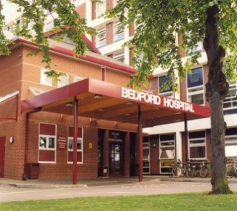  All About  Me |  | 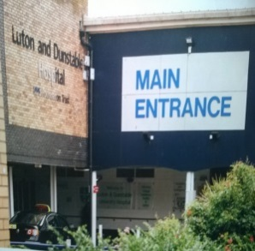
My name is;
I like to be called;
My NHS Number is;
Please read,
important information about me.
It needs to be at the end of my bed. A copy should also be put in my notes.
If I need support before or during my stay in hospital the liaison nurses may be able to help. Contact them on:
07768132244 East London Foundation NHS Trust
07854356498 East London Foundation NHS Trust

If I need support after I leave hospital the Community Health Facilitation Service may be able to help.
Contact them on:
Central Bedfordshire Mob: 07983410519
Bedford Mob: 07973231509

This Hospital Passport is based on original work by Gloucester Partnership NHS Trust and subsequent work by Bedford Partnership NHS
CONSENT TO INFORMATION SHARING AND IMPORTANT INFORMATION
This Hospital Passport should be completed by you and the people who know you best.
By filling it in, you are consenting to your information being shared with the hospital and the staff who are caring for you.
The All About Me gives the hospital staff important information about you including any Reasonable Adjustments you may need to ensure that you get the best care, given in the right way for you. You can ask the hospital to take a photocopy and keep it in your file, to make sure hospital staff can access the information quickly.
Before you leave hospital make sure the Hospital Discharge Information Plan has been completed and remember to take your “All About Me” home with you.
Before you leave or once you are home you may also want to fill in the Have your say questionnaire to tell the hospital about your experience. This will help them to improve their service.
Please let your local Health Facilitation Service know that you are going into hospital as the Health Facilitation Nurses will be able to offer you advice and support before, during and after your hospital stay.
Central Bedfordshire Health Facilitation Service Tel: 07983410519 (01234 310589)

Bedford Health Facilitation Service Tel: 07973231509 (01234 310589)

Alternatively contact the Hospital Learning Disability Liaison Nurses
Mobile:07768132244 Mobile: 07854356498

You can also discuss any worries or concerns you may have with the manager of the ward or department you are attending.
Any decisions made about your capacity to consent to treatment, best interests and resuscitation status must be made in consultation with you, your next of kin, your cares and other professionals.
This is my personal property and I consent to this information being held at the end of my bed and shared with the Hospital staff. I also agree to the Hospital saving my “All About Me” electronically if needed/able.
NAME |  |  | SIGNED (by the person or in their best interest in accordance with MCA (2005) | DATE

Mental Capacity Act 2005
Never assume I lack capacity, if unsure undertake a capacity assessment on the Trust template before making decisions on my behalf.
If it has been assessed that I lack the capacity to make a specific decision about my care or individual treatment a formal Best Interest decision must be made and documented on the trust template, this decision should be made with people who know me well i.e. my next of kin or IMCA and Carers (if no next of kin) the person proposing and carrying out the treatment will be the person that will sign the consent form.
If I have a next of Kin and they have Lasting Power of Attorney or deputyship etc. relating to my health, please ask to see paperwork before discussing my treatment.
NAME OF THE PERSON WHO SHOULD BE CONSULTED AND INVOLVED IN THE CAPACITY ASSESSMENT AND BEST INTEREST DECISION PROCESS:
RELATIONSHIP:
PHONE NUMBER:
If treatment or physical intervention is needed has this been agreed in best interest and recorded accordingly? (Please circle)
 | Yes |  |  |  | No
DATE AGREED:
If physical intervention is required during my stay in Hospital my family and/or carers need to consider how this can be implemented and recorded. All Physical intervention Plans should be shared with Hospital staff prior to or during the admission process. Hospital staff will not engage in physical Intervention unless the safety of the patient or others is in serious and immediate risk.

Reasonable Adjustments
(HOW BEST SUPPORT ME)
Equality and Diversity ACT 2010
Reasonable adjustments that need to be considered when going into hospital
For example –a side room, my carers to be able to come and support me to help me communicate etc., if planned procedure make provisions with me, family/carers to discuss my specific needs beforehand, prior visits to help with familiarity/de-sensitisation.
Identified adjustment | Reason/Rationale

Things you must know about me (Personal details)

 |  |  | Date of Birth
 |  |  | Address
 |  |  | Telephone
 |  |  | Current Living Environment |  | (Current living environment e.g. Flat, bungalow, level of support funded/non funded i.e. 24 hour support.)  (Any Legal status i.e under Section/DoLS)
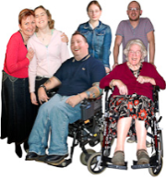 |  |  | Primary contact  (Next Of Kin)
 |  |  | Relationship
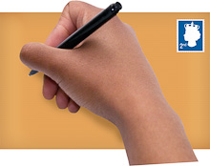 |  |  | Address
 |  |  | Telephone
 |  |  | Current Diagnosis |  | e.g. level of Learning Disability and any other physical or mental health conditions.
Things you must know about me (Personal details)

 | Religion
 | Religious needs
 | Ethnicity
 | Dr GP
 | Address
 | Telephone
 | Other services and professionals involved with me
 | Allergies
Risk of choking
when eating,
drinking or
swallowing
 | Height -
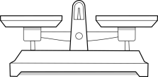 | Weight -
Things you must know about me (My Health and Wellbeing)

 | My heart or breathing problems
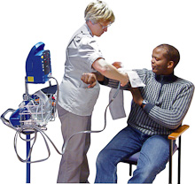 | Medical interventions (how to take my blood, blood pressure, give injections)
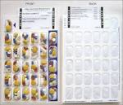 | My current medication |  |  |  |  |  | Medication correct at time of entry. Please check my current medication (ask for a MAR sheet).  Has My Medication been ordered and provided by hospital pharmacy department YES NO
 | Operations and illnesses I have had
Things you must know about me
(How I communicate)
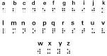
Do I have a Communication Passport (please Circle)
 |  | YES |  |  |  |  |  | NO
If yes please ask my family/carer for a copy it is very important that you communicate with me consistently
How to communicate with me (e.g. speaking, signing, pictures, simple sentences) |  |  |  |  |  | How I communicate  (e.g. any communication aid they may use etc.)
Things you must know about me
(How to support me if I’m worried or upset)
When I’m happy I will; |  |  |  |  |  | How to support me to be happy
When I start to get upset or angry I will; |  |  |  |  |  | How to support me to keep calm and be happy (consider pain relief)
When I’m angry and upset I will; |  |  |  |  |  | How to support me when upset

Things that are important to me (Daily Activities)
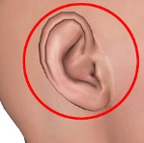  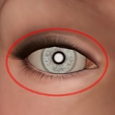 | Problems with my sight and hearing | (Eg. Say if I have a better ‘side’ for you to approach me, whether I can lip read, if certain lights bother me, or I’m sensitive to noise,)
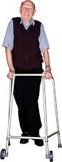 | How I move around (such as walking aids, posture in bed)
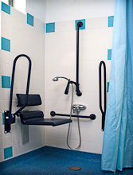 | My personal care (such as dressing, washing)
 | How I use the toilet (such as continence aids, help to get to the toilet)

Things that are important to me (Daily Activities)
 | How I eat (such as needing food cut up, risk of choking, help with eating) | (Eg: my favourite food and drinks, things I particularly dislike, whether I have a specific health, personal or cultural diet)
 | How I drink (such as small amounts, thickened fluids) | (E.g. special equipment, Nasogastric tube, Gastrostomy tube, special cup)
 | How I sleep (such as sleep patterns, routines)
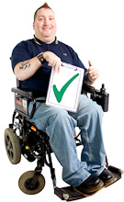 | What support is best for me to keep me safe | Do I wander  Could fall out of bed  Do I need bed rails  I need routine and predictability

Things you must know about me
Things I like
e.g. what makes me happy, things I like to do such as watching TV, reading, music and my routines
Things I don't like
e.g. crowds, loud noises, some food and being touched.

Things I like |  |  |  | Things I don't like
 |  | Please do these things |  |  |  | Don't do these things
Completed by: |  |  | Date: |  | Review Date:

Discharge
What people need to do before I leave hospital:

What happened while I was in hospital?
(e.g. treatments, surgery, investigations, procedures)

When planning for me to go home you need to talk to:
Example:- Social Worker, Care Manager, carers, Family. You may need to have a meeting before I go home.

What’s changed?
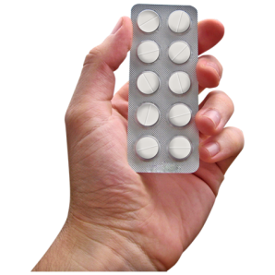
About my health, medication (new/change/stop) and support needs?

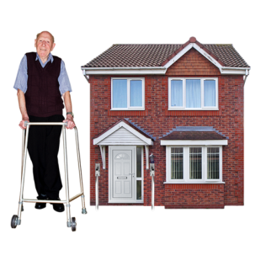
What has to happen at home so that I stay safe and well?
(e.g. care package, change of address, equipment, health advice).

What do I need now?
To make sure my changed needs around health, medication or support are met? (E.g. ask pharmacy to make sure my medication is in a blister pack when I am discharged)

Do I need to come back to hospital for anything after I go home?
Do I need to see any other professionals?
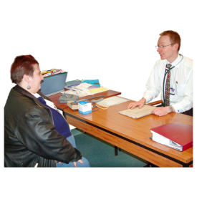

I will need transport to get home from hospital:
(Please circle)
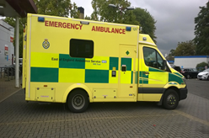
Yes No

Please plan my transport/discharge so I can go home during the day not at night time.

When I am given my discharge letter/information(above) if it is felt I am unable to understand the contents you must ensure my family/carers receive the information.

This “All About Me” belongs to me.
Please return it when I am discharged.

