Managing Allegations and Concerns about Adults who work with Children

PRACTICE GUIDANCE

For LADOs

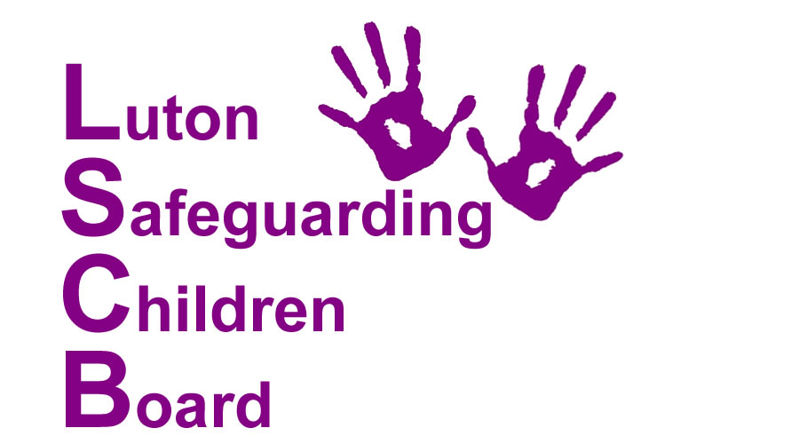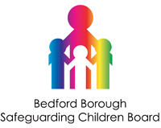

Introduction

The aim of this document is to enable agencies to work effectively together in the process of managing allegations or concerns against adults who work with children. This is a joint protocol between Luton, and Bedford Borough Councils and Bedfordshire Police. The protocol should be used in conjunction with the Bedfordshire and Luton LSCB Allegations Management Procedures.

Key Principles
- The welfare of the child is paramount. Safeguarding children is the act we take to promote the welfare of children and protect them from harm, children should be central to the process of the management of all allegation.
- Adults about whom there are concerns should be treated fairly and honestly and should be provided with support. The employers of those subject to an allegation or concern have a duty of care towards them.
- It is important to ensure that even apparently less serious allegations are seen to be followed up, and that they are examined objectively by someone independent of the organisation concerned. Each Local Authority designates an officer (LADO) whose role is to provide management and oversight of individual cases, liaise with other agencies and ensure cases are dealt with as quickly as possible, consistent with a fair and thorough process.
- The scope of inter-agency procedures in this area is not limited to allegations involving significant harm or the risk of significant harm to a child.

Definition of an allegation

An allegation or concern that any person who works with children, in conjunction with his/her employment in either a paid or unpaid capacity, or voluntary activity has;

- behaved in a way that has harmed a child, or may have harmed a child;
- possibly committed a criminal offence against or related to a child; or
- behaved towards a child or children in a way that indicates they may pose a risk of harm to children.

Case Management Model (see appendices)
Not all allegations or concerns require the same level of response, therefore referrals are managed in line with the following model;

1) Consultation

A referral to the LADO which, after consideration, is deemed not to meet the definition of an allegation/concern (pg2).

Examples could include the following although this is not an exhaustive list;

- the subject of the allegation/concern cannot be considered to be ‘an adult who works with children’
- there is no identifiable safeguarding children concern
- where the adult concerned cannot be identified
- The allegation/concern is more appropriately described as a practice issue and should be dealt with by the employer.

In these situations the LADO will record that a consultation has taken place, the name of the professional and agency making the contact, brief details of the circumstances and basic details of the adult under discussion. It is important that these details are recorded and could be drawn upon if further concerns come about in relation to that individual. In addition a recent national SCR criticised LADO for not recording information at the consultation stage. It is also provides a record that ‘a risk was not identified’ about the individual.

2) Tier 2 referral
The referral does meet the definition of an allegation and therefore, for statistical purposes, is recorded as such. The strategy required for dealing with a case at this level is less complex than at Tier 1 and typically needs less ‘active’ management by the LADO or other agencies. In such cases the employer is best placed to manage the matter to its conclusions. The LADO is however available and actively monitors timescales and quality assures the outcome. Details regarding this referral will be recorded by the LADO in line with the suggested data set outlined in Section 4 Recording.

An example coming within this category could be:

- a nursery worker has handled a child in an aggressive manner – the child is 3 years old - it is alleged he was grabbed by the arm tightly, pulled by his arm and shouted at. He did not receive an injury. There have been no previous concerns about the worker and there are no other factors which require the case to be escalated.

3) Tier 1 referral
The referral clearly meets the definition of an allegation / serious concern and requires active management by the LADO and other agencies, as appropriate.

All cases of physical, sexual, emotional abuse or neglect (as defined by Working Together 2013) or serious concerns about the potential risk of harm a person may pose to children will be managed at Tier 1. There may be occasions where apparently less complex or serious cases are managed as Tier 1. For example when a pattern of allegations are emerging or there is an additional complicating factor which requires active management.

Examples of Tier 1 Cases could include the following, although this is not an exhaustive list:

- Allegations which require the involvement of other agencies such as the police or children’s social care
- Any allegation of abuse as defined by Working Together 2013
- An allegation which is complicated by the number of victims/perpetrators/ or roles held and will include those situations that relate to any possible breach of a position of trust.
- A pattern of allegations/concerns are emerging.
- Other complicating factors including interest by a third party such as the media.

In Tier 1 cases a Strategy Meeting, or a meeting convened by the LADO will be held.

Assessing criteria 3 - an allegation or concern which indicates the adult may pose a risk of harm to children
There may be occasions when an adult’s behaviour, either within the workplace, or the adult’s personal life, gives rise to concerns about their suitability to work with children. The employer, in conjunction with other appropriate agencies, may need to make a judgement about the possible impact of that behaviour upon the children they come in to contact with in their role. What constitutes a risk will vary depending upon the context and nature of the work the adult is involved in.

Examples which may indicate an adult may pose a risk include:
- Information which suggests the adult may have a sexual interest in children. This includes adults alleged to have downloaded Indecent Images of Children (IIOC)
- The adult is under investigation for abuse or neglect of their own children
- An allegation of historic sexual abuse
- The adult is involved in crime, including perpetrators of Domestic Abuse or the supply illegal substances.
There are other scenarios where the risk to children is less clear and requires careful consideration at the point of referral. In such cases the adult may be the injured party or vulnerable in some other way. It is important that the potential risk is carefully balanced with the risk of further victimisation of the adult concerned. Examples include adults who are victims of Domestic Abuse, are experiencing mental health problems or suffering as a result of alcohol or substance misuse. In these circumstances it will be necessary to evidence a direct impact of this on his/her role with children before considering this within the allegations procedures.

Children’s Social Care

All allegations or concerns which, at the point of referral, show the potential for meeting the definition of significant harm should be referred to the relevant team in Children’s Social Care. In these circumstances a strategy meeting in line with the Inter-agency Safeguarding Children procedures should be called. The meeting should be chaired by the relevant manager within the team and the LADO should be invited. If further strategy meetings are not required consideration should be given to transferring the management of the case to the LADO. If transferred, any future meetings held will be meetings chaired by the LADO.

Bedfordshire Police
Allegations are to be referred to Bedfordshire Police for two reasons:

- To consider the need for police to investigate an alleged crime
- To enable information sharing and aid decision making relating potential risk to children;

The nature of allegations or concerns referred to the LADO varies considerably. In some circumstances an allegation may technically meet the definition of a crime (eg Assault or Battery) however a criminal investigation seems a disproportionate response. There is also a need to distinguish between allegations of assault and the legitimate use of physical intervention or restraint to protect a child/children from harming themselves or others, or damaging property.

By the same token, inappropriate behaviour toward a child by a person in a position of trust should be taken seriously and considered an aggravating factor when assessing the need for police involvement. In many cases the use of physical chastisement by adults in such positions has been outlawed and should be considered accordingly. The child does not have to be injured or marked in order for the matter to be considered a criminal offence. It should also be recognised that the police hold the expertise on the definition of an offence and may consider offences outside the knowledge of professionals in other agencies.

We would always refer to the police in cases where:

- There is injury or reported injury ( to include minor injury such as a red mark)
- All allegations of sexual abuse, including concerns about an adult’s behaviour which may indicate a sexual interest in children.
- An allegation of battery where there is no injury but there are other aggravating factors such as (i) a previous pattern of this behaviour (ii) the level of violence, threat of violence, or premeditation which escalates the level of concern (iii) the underlying intent is believed to be to cause harm to the child.
- Despite the allegation being low level another factor, such as the wishes of the child or the parent means that police consultation is required.
- There is any additional vulnerability of the child.

In these cases police would be expected to contribute to the meeting chaired by the LADO.

It may still be necessary for police to attend the Strategy Meeting or meeting chaired by the LADO to gather further information and contribute to the decision making. In turn information recorded by police may be used to inform future Disclosure and Barring Service disclosures.

Suggested Recording Data Set:
Where an allegation is made and meets the criteria for either Tier 1 or Tier 2 the following data should be captured:
Name, Address, Date of Birth, gender and ethnicity of the adult and the victim;
Details of the referring agency;
Details of the employing agency; role/occupation
How did allegation come to light –
Category of abuse (physical, sexual, neglect, conduct etc); date of incident (historic if over 12 months ago)
Case management Tier (ie 1,2 )
How the risk was managed – ie suspended /restricted duties
How allegation was investigated – criminal S47; disciplinary etc and outcome of investigations
Referral to and date of DBS referral – and details of referral to any other body
Conclusion category and date of conclusion timescale for case
Summary of the allegation.
APPENDIX 1
Case Management Model
Tier 2: Monitoring only
The referral does meet the definition of an allegation and therefore, for statistical purposes, is recorded as such. The strategy required for dealing with a case at this level is less complex than at Tier 1 and typically needs less ‘active’ management by the LADO or other agencies. In such cases the employer is best placed to manage the matter to its conclusions. The LADO is however available and actively monitors timescales and quality assures the outcome
Tier 1:
Active case
- Allegations which require the involvement of other agencies such as the police or children’s social care
- Any allegation of abuse as defined by Working Together 2013
- An allegation which is complicated by the number of victims / perpetrators / or roles held and will include those situations that relate to any possible breach of a position of trust.
- A pattern of allegations / concerns are emerging.
- Other complicating factors including interest by a third party such as the media.
(not an exhaustive list)

Consultation
Does not meet the threshold
- the subject of the allegation/concern cannot be considered to be ‘an adult who works with children’
- there is no identifiable safeguarding children concern
- where the adult concerned cannot be identified
- The allegation/concern is more appropriately described as a practice issue and should be dealt with by the employer
(not an exhaustive list)

