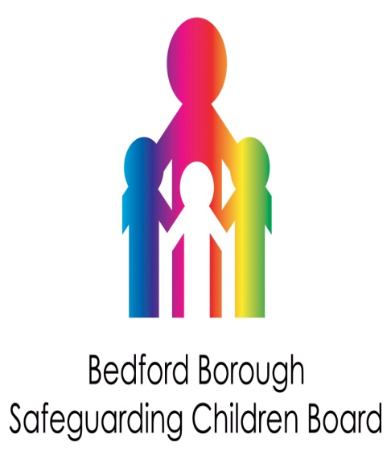
Discussion item for team/staff meetings

Learning from case reviews involving people who first language is not English

(NSPCC briefing December 2013)

This briefing is based on serious case reviews published since 2008, where family members do not have English as their first language. It pulls together and highlights the learning contained in the published reports.
Good communication is key to relationships between professionals and service users. A lack of a common language presents a significant barrier to building trust.
Risk factors
There are a number of factors which increase the level of risk when one or other parent does not speak English well.
Imbalance of power
An imbalance of power may exist between the two parents where one parent speaks English and the other does not. The English speaking parent can effectively act as a filter through which all their partner's contact with the outside world takes place. This can significantly impair the non-English speaking partner's access to help and support outside the family.
Where parents have different first languages it can also impair their ability to discuss and resolve issues together.
Where some of the family speak English and others do not, there is a risk that professionals do not engage with the non-English speaking family members. This can mean the professionals do not get a complete picture of family life and so may be unaware of abusive partners or of the support that the non-English speakers need.
Lack of confidential space
Using neighbours, friends, children or partners as informal interpreters removes the individual's ability to speak to professionals in confidence. This therefore reduces the chance that abuse will be disclosed.
Child involement in adult topics
Children who have grown up in the UK often serve as interpreters for their parents. This can mean children are asked to translate adult conversations relating to child/domestic abuse which are inappropriate for their age.
Social isolation
Families living in areas where their language is not widely spoken can feel isolated from their local community. Both parents and children lack social support networks. This can lead to problems with depression and a belief that there is no one able to help them.
Misreading of indicators of abuse
Children's delayed speech, withdrawn behaviour, or unwillingness to talk to professionals can be misinterpreted as issues related to a lack of English, as opposed to potential signs of abuse or neglect. Similarly, abusive parents may over-emphasise their lack of English as a means of withholding information from, or co-operation with, agencies.
Lessons for improving practice
Awareness of language issues
When working with families where you suspect or know that English is not the first language always check that what you are saying has been understood.
If you suspect that there are comprehension issues, establish as early as possible what language they would prefer to speak in and arrange interpretation services accordingly.
When making initial contact with a family be aware that you may not be fully understood. Bear in mind that a failure to respond or attend appointments may have more to do with a lack of comprehension than engagement. Follow up contacts, ideally with a home visit.
Recording first language
Clearly record language needs from the outset of your work. Make sure that this information is shared with other agencies involved, so that follow-up communications can take place in the appropriate language.
Written communication
Write to families in their first language. The service user's spoken English may be of a higher level that their written English. Also bear in mind that literacy may be an issue, and that another form of communication may be more appropriate.
Use of interpreters
Use professional interpreters when speaking to service users who do not speak English fluently. Interpretation services should also be available in emergency settings (eg A&E).
Speak to individual members of the family alone. Do not allow family members, neighbours or friends to translate or speak on another person's behalf.
If parents are reluctant to use interpreters, try to establish the reason for their reluctance. Women may be uncomfortable speaking through a male interpreter.
Where good communication is vital, for example during assessments, do not readily accept a family's initial refusal to use an interpreter. Continued refusal to use an interpreter should be recorded and treated as part of any assessment of child protection concerns.

