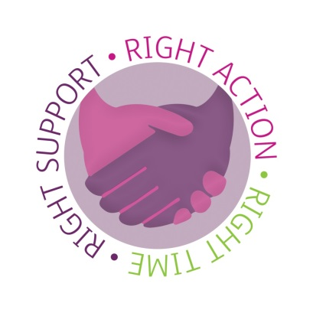
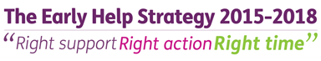

Early Help Strategy Consultation Report

- Introduction
  - Bedford Borough Council consulted on a draft Early Help Strategy for almost two months through January and February 2015.

  - The Council undertook an initial period of consultation on Early Help services and support in Bedford Borough during the summer of 2014. Following this, the council together with its partner agencies began work on the draft Early Help Strategy in Autumn of 2014.The Early Help Strategy will set out strategic priorities for Early Help services and support in Bedford Borough, as well detailing a clear proposal for implementation of the Strategy.

  - Whilst the initial consultation provided vital intelligence which helped shape the draft document, it was felt a further consultation was required to ensure we got it right. The Council is committed to engaging with communities in the development of its Strategies and there were a number of ways the community was able to get involved.

  - The purpose of the second phase of consultation stage was:
- to inform partners about the draft Early Help Strategy
- to seek views from partners on the draft Strategy
- to widen and deepen the involvement of partner agencies in the delivery of the strategy
- to ensure our strategy is achievable

  - This report provides an overview of how we sought to involve people in the consultation and sets out an overview of the written responses we received. It also briefly outlines the next steps.

- How we engaged with the community
  - The Early Help Strategy with a covering consultation document was widely distributed to all partners including schools and parish councils within Bedford Borough. The consultation was also listed on the Bedford Borough consultation pages of the website and a link to the consultation was tweeted from the @bedfordtweets account which has over 6,000 followers.
2.2 Interested parties were able to respond to the consultation in one or more of the following ways:
- Complete an online response form
- Email consultingbedford@bedford.gov.uk
- Writing to Consulting Bedford, FREEPOST ANG5840, Bedford MK40 1ZD
- A 1 – 1 meeting to explore the strategy further
- Request the attendance of the Early Help Project officer at a cluster meeting to explore the strategy further

- Consultation Involvement
  - Community participation in the consultation was as follows:
- 24 online form / email submissions (4 Bedford Borough employees, 16 partner agencies and 4 members of the public
- 9 one to one visits with headteachers
- 7 group visits including 3 cluster meetings, 2 governor briefings, 1 safeguarding lead forum and 1 practitioner forum
- 2 parent sessions involving 22 parents.

- Consultation feedback
  - An overview of responses within 4 main themes discussed through the consultation is detailed below:
Views on the strategy document as a whole
There was a very positive response to the principles and vision outlined in the draft strategy. Some felt they needed to be tightened up and made more concrete.
Respondents were very clear that there were currently gaps in Early Help provision in Bedford Borough. There was a widespread view that statutory services have become clogged due to an absence of other options for referees.
Many respondents discussed thresholds as being an issue and felt as referers they didn’t have a clear understand of what is‘social care’ and what is‘early help’.
Some respondents felt that the strategy was too ‘theoretical and philosophical’ and needed to include more detail on implementation and how the vision was going to be achieved.
Generally responses were positive about the direction of travel noted within the strategy. Some noted that it will only be a successful strategy if all partners sign up to support it.
Views on locality delivery
There was a general consensus in responses that the Locality Network Panels have not achieved what they had intended to in conception. Respondents who had accessed them had found the discussion and opportunity to share their situation helpful, but felt there was no positive outcomes achieved other than this.
Respondents who were involved in a locality group or cluster meeting found the networking and opportunity to share practice within their cluster very helpful. It was felt this model also served to develop transitional arrangements between school settings.
Generally respondents felt a school cluster approach was sensible. There was some discussion around the Catholic Federation of Schools and how we ensure that they receive an equitable offer.
There was also discussion around the Early Years workforce and the health workforce and how it will be vital to include them in the school clusters.
Views on access to services and referrals
There was unanimous agreement that a ‘one front door’ approach to referrals would be of great benefit.
There was also a wide agreement that the Common Assessment Framework was under used and unhelpful to complete. Many respondents felt that a shorter, simpler assessment form should be developed. A few also made the suggestion that this form should be the only form used by services to make processes simpler.
Many respondents commented that when making a referral for Early Help, they needed a fast response. The Locality Network Panel system required them to wait up to a month for a panel which was far too long.
Views on the Early Help Directory
The possibility of an online directory of services and support for Early Help was widely welcomed and noted as a good idea. Parental responses at one of the baby groups attended gave a very helpful insight into how the directory should be advertised. It was felt here that information about the directory should be given out by midwives antenatally to ensure families had the information at the earliest opportunity.

Some respondents noted that it would be vital to keep the information included on the website up to date to prevent confusion/disappointment.

- Outcomes of the consultation
  - As a direct result of the consultation the strategy was amended to reflect the responses. The strategy has since been adopted by the Executive Committee within the Borough Council and will be presented to the Bedford Borough Safeguarding Children’s Board and the Children’s Health and Wellbeing Group over the coming month.
  - A few other outcomes of particular note are:
    - The agreement to develop a new Bedford Borough Early Help Assessment process to replace the CAF
    - The agreement to recruit 8 new members of staff to form the Early Help Team who will support the implementation of the strategy.
    - The agreement to put in place a ‘One Front Door’ system where all referrals for Early Help are dealt with from within the MASH.
    - Information about the Early Help Directory will be handed out antenatally to ensure families have information as early as possible.

