Bedford Borough Council – CCTV Control Room
Key Performance Indicators - 1st April 19 – 31st March 20

Indicator Details | Apr 19 | May 19 | Jun 19 | July 19 | Aug 19 | Sept 19 | Oct 19 | Nov 19 | Dec 19 | Jan 20 | Feb 20 | Mar  20 | Total
Police requests | 27 | 24 | 34 | 34 | 33 | 19 | 21 | 35 | 41 | 29 | 25 | 39 | 361
Beds Safe – Night Time Economy | 13 | 5 | 35 | 9 | 18 | 11 | 7 | 19 | 16 | 10 | 7 | 8 | 102
Blue Caps – Retail Customer Service | 1 | 0 | 0 | 0 | 2 | 0 | 0 | 2 | 1 | 0 | 0 | 1 | 7
Retail Radio – Town Centre Commerce | 19 | 22 | 12 | 20 | 17 | 26 | 23 | 25 | 30 | 18 | 22 | 23 | 257
Bedford Borough Council | 1 | 0 | 0 | 0 | 0 | 0 | 0 | 1 | 0 | 0 | 0 | 1 | 3
Fire Service | 0 | 0 | 0 | 0 | 0 | 0 | 0 | 0 | 0 | 0 | 1 | 0 | 1
CCTV Control Room | 54 | 37 | 49 | 69 | 55 | 38 | 42 | 44 | 39 | 81 | 69 | 49 | 626
Parking Services | 1 | 0 | 2 | 1 | 6 | 0 | 3 | 3 | 3 | 2 | 2 | 2 | 25
Arrests – All above sources | 46 | 39 | 46 | 46 | 41 | 23 | 37 | 45 | 47 | 56 | 35 | 42 | 503
Footage Requested | 28 | 39 | 50 | 35 | 41 | 34 | 32 | 31 | 30 | 41 | 40 | 29 | 430
Footage Destroyed – (Requested but not collected) | - | - | - | - | - | - | - | - | - | - | - | - | 22
Footage Awaiting Collection | - | - | - | - | - | - | - | - | - | - | - | - | 67

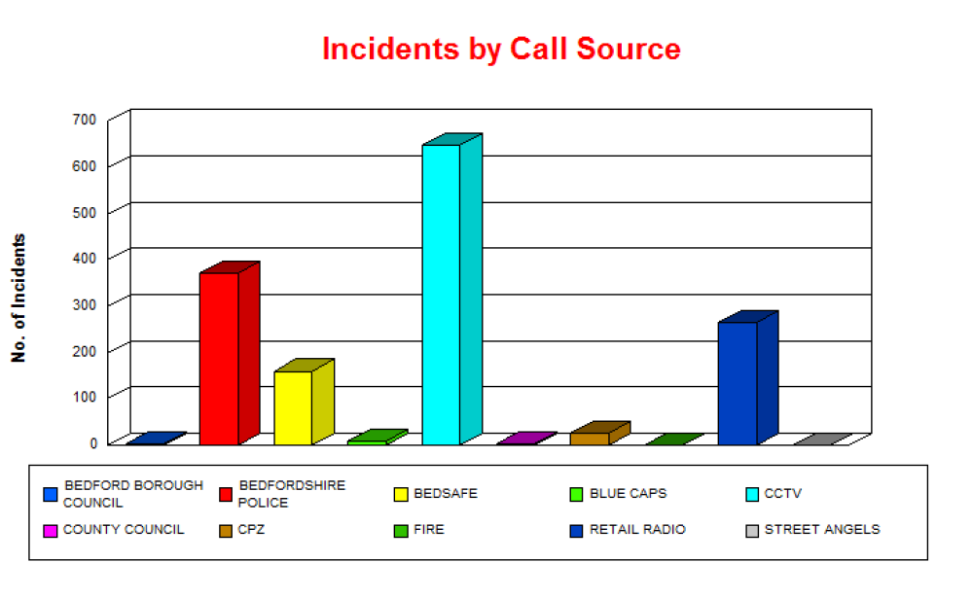
Indicator Details for the period 1st April 2020 – 31st March 2020

