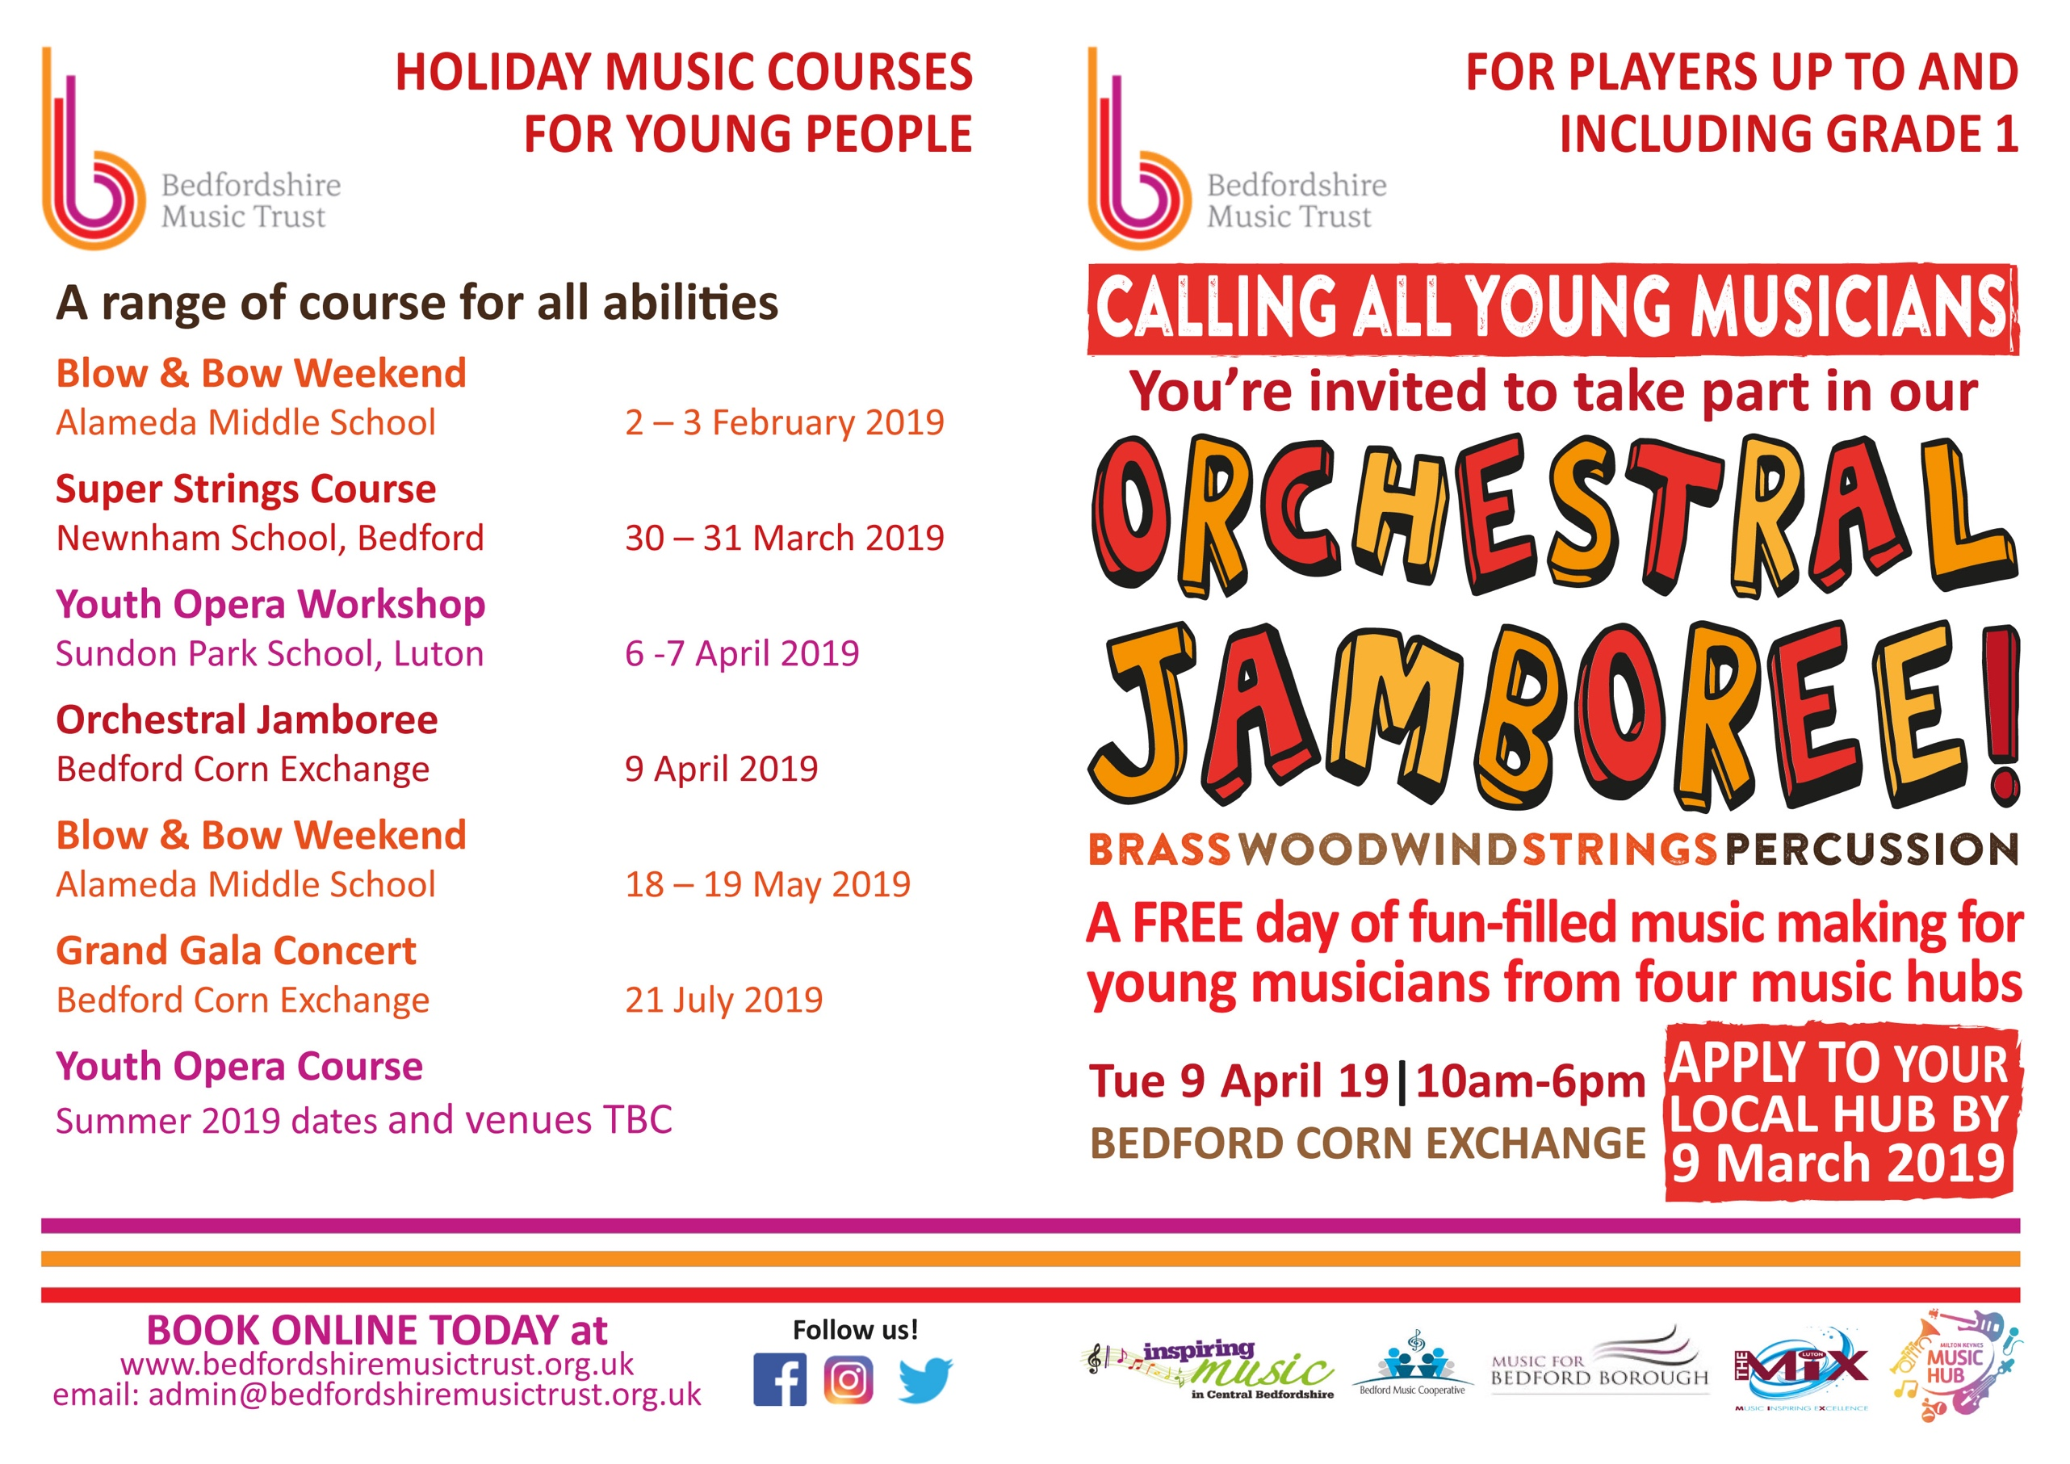

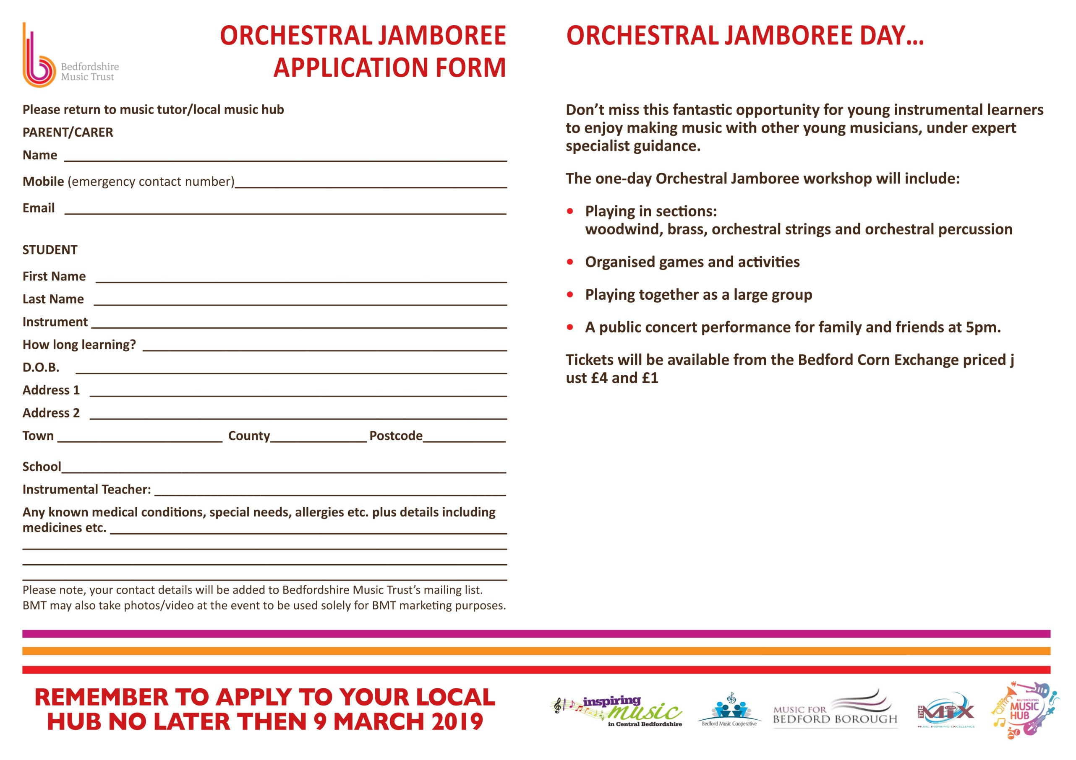

**Bedford Music Hub**

Email applications to [music@bedford.gov.uk](mailto:music@bedford.gov.uk) or by post to:

Bedford Music Hub, Castle Newnham School, Polhill Avenue, Bedford, MK41 9DT