Apply Online

Go to Apply Online page. www.bedford.gov.uk/onlineadmissions

At bottom of page click on Apply Online Here.

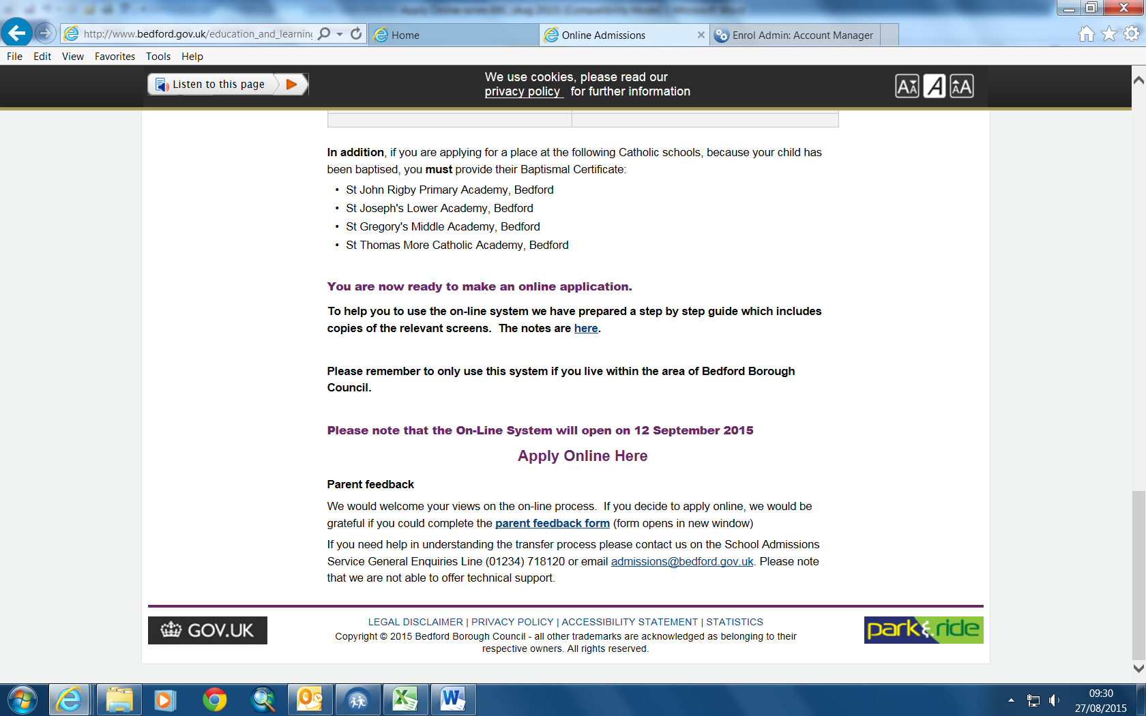

This will take you to the page below: This page gives details of the admissions rounds that are available online.

NB You must only use this system if you live in the area covered by Bedford Borough Council. ( If your child lives in Central Bedfordshire their online system is available at www.centralbedfordshire.gov.uk/onlineadmissions )

To create a new account, use the “Create Account” link. If you already have an account use the “Log in” link. However, periodically we delete all old accounts to free up space to make the system run more efficiently.

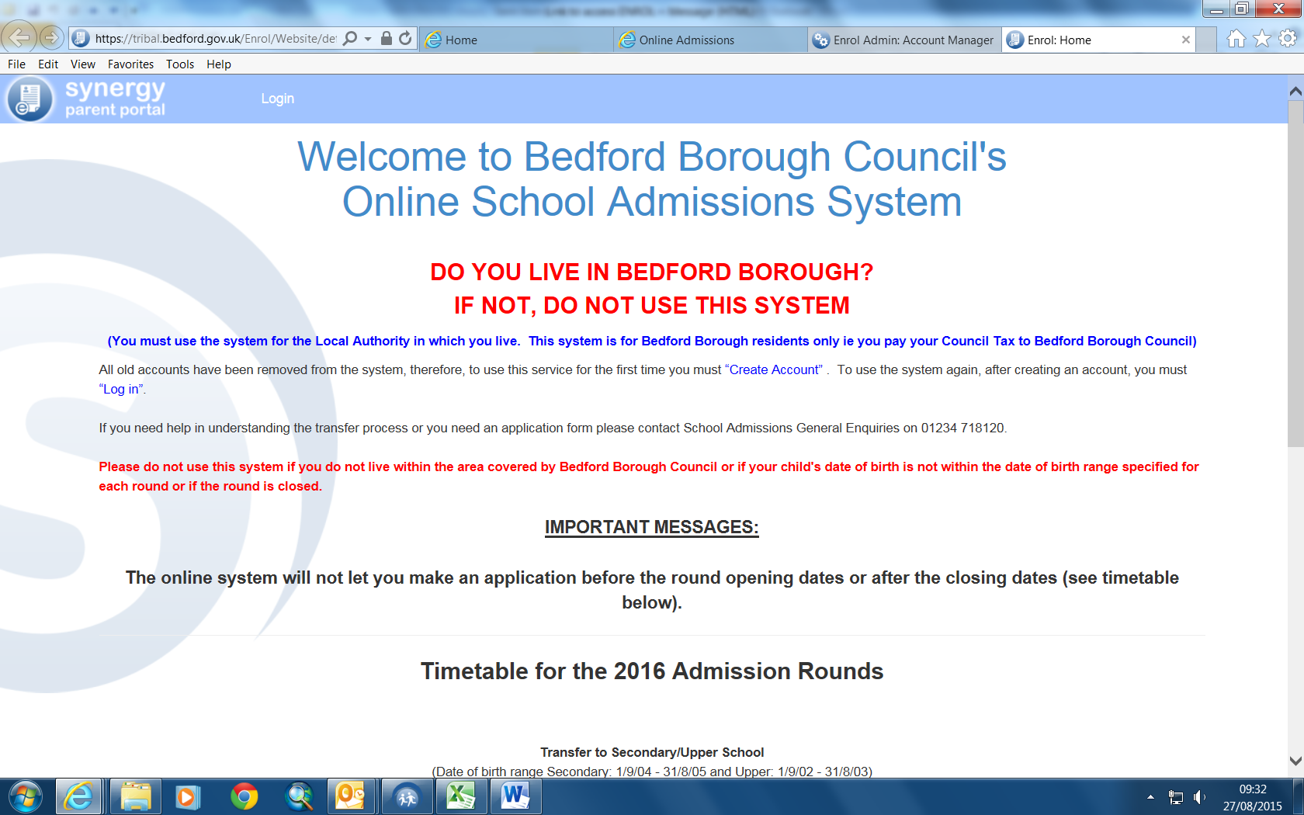

To create an account the boxes marked with * must be completed.

Please read the notes at the top of the page carefully, particularly the sentence about “Notification Preference”.

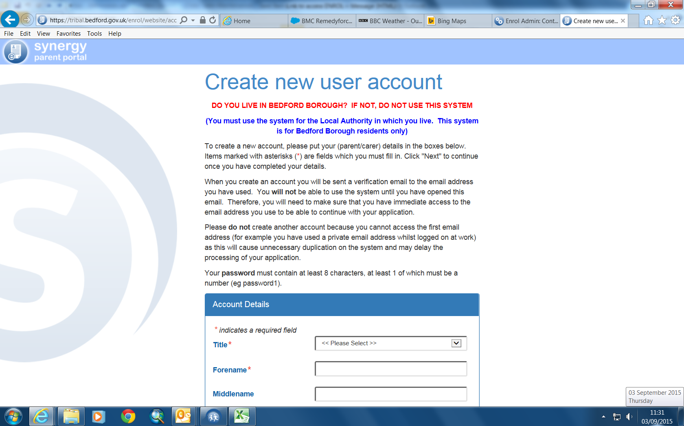

Enter details as below

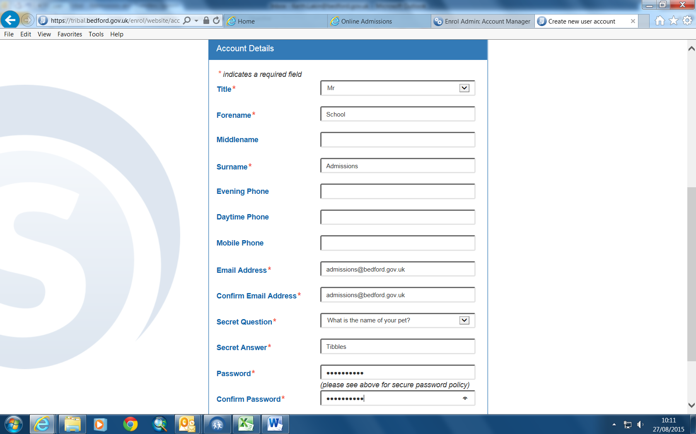

Click Next

This screen will come up to allow you as the applicant to find your address.

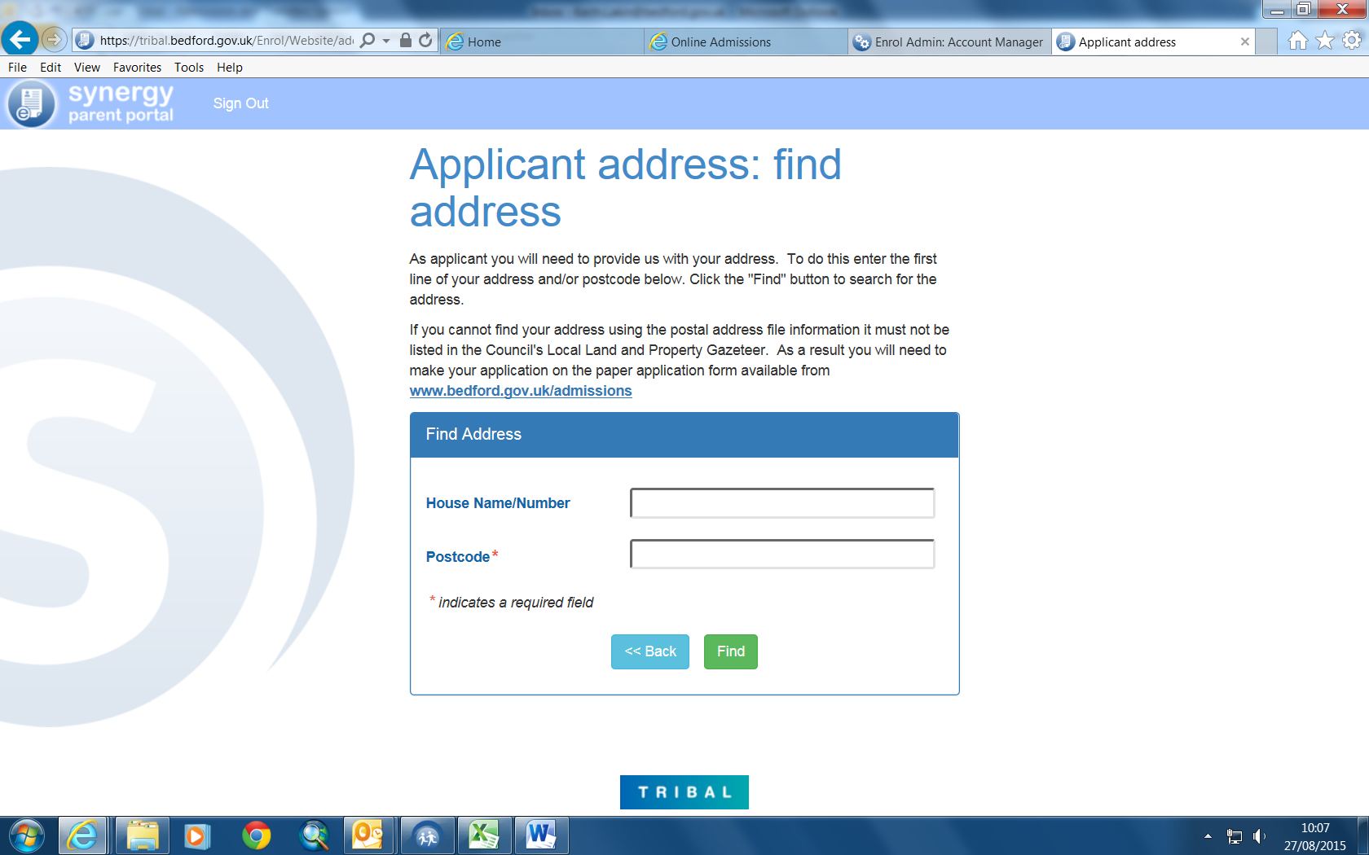

To do this type your postcode and then click find.

This must be a Bedford Borough address

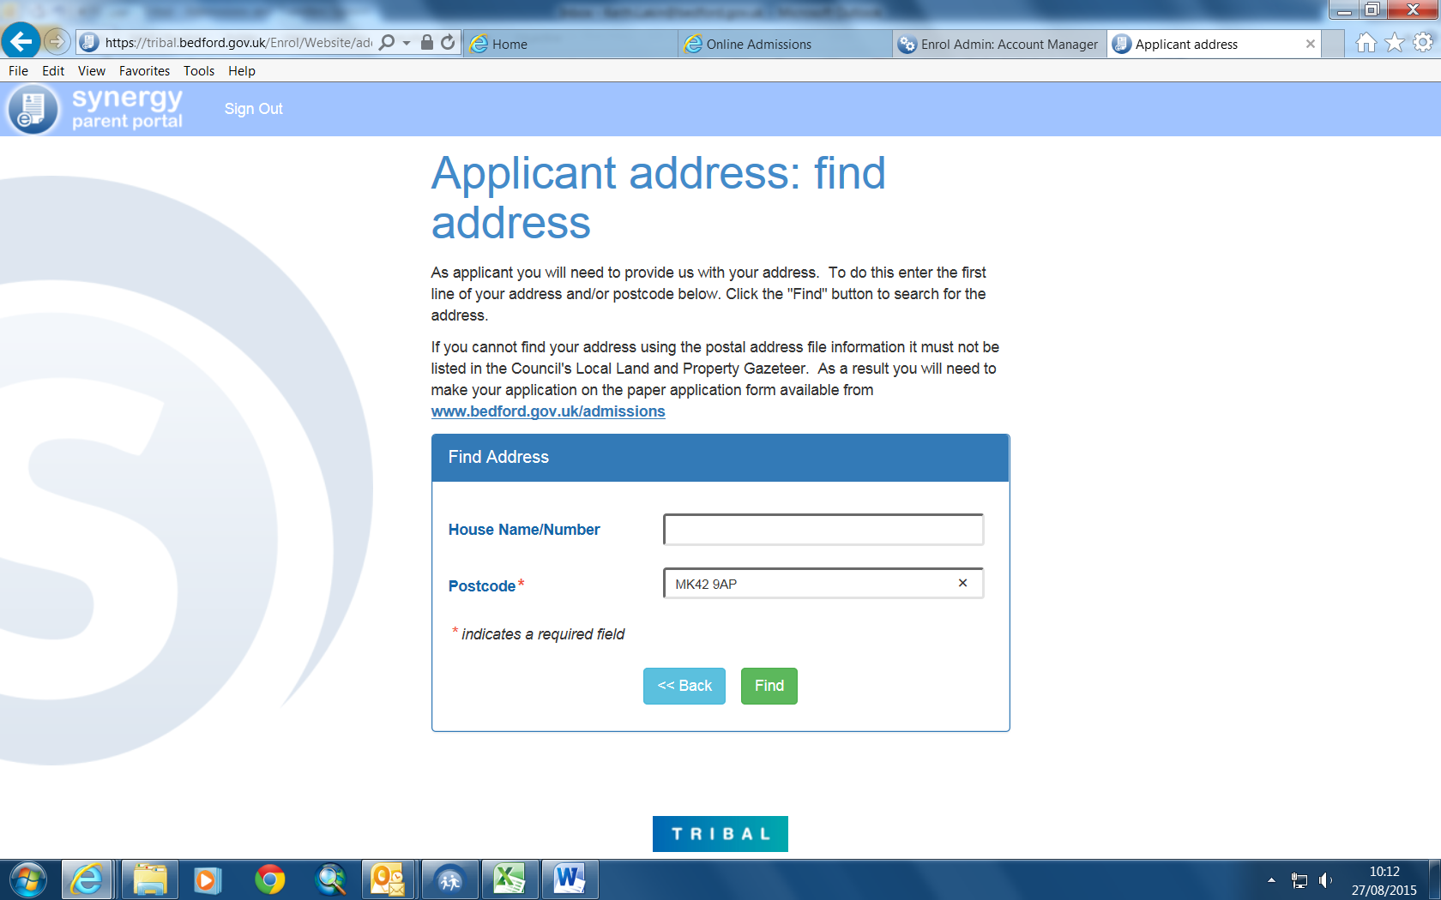

Most addresses will be found.
Select your address from the list that appears and press select

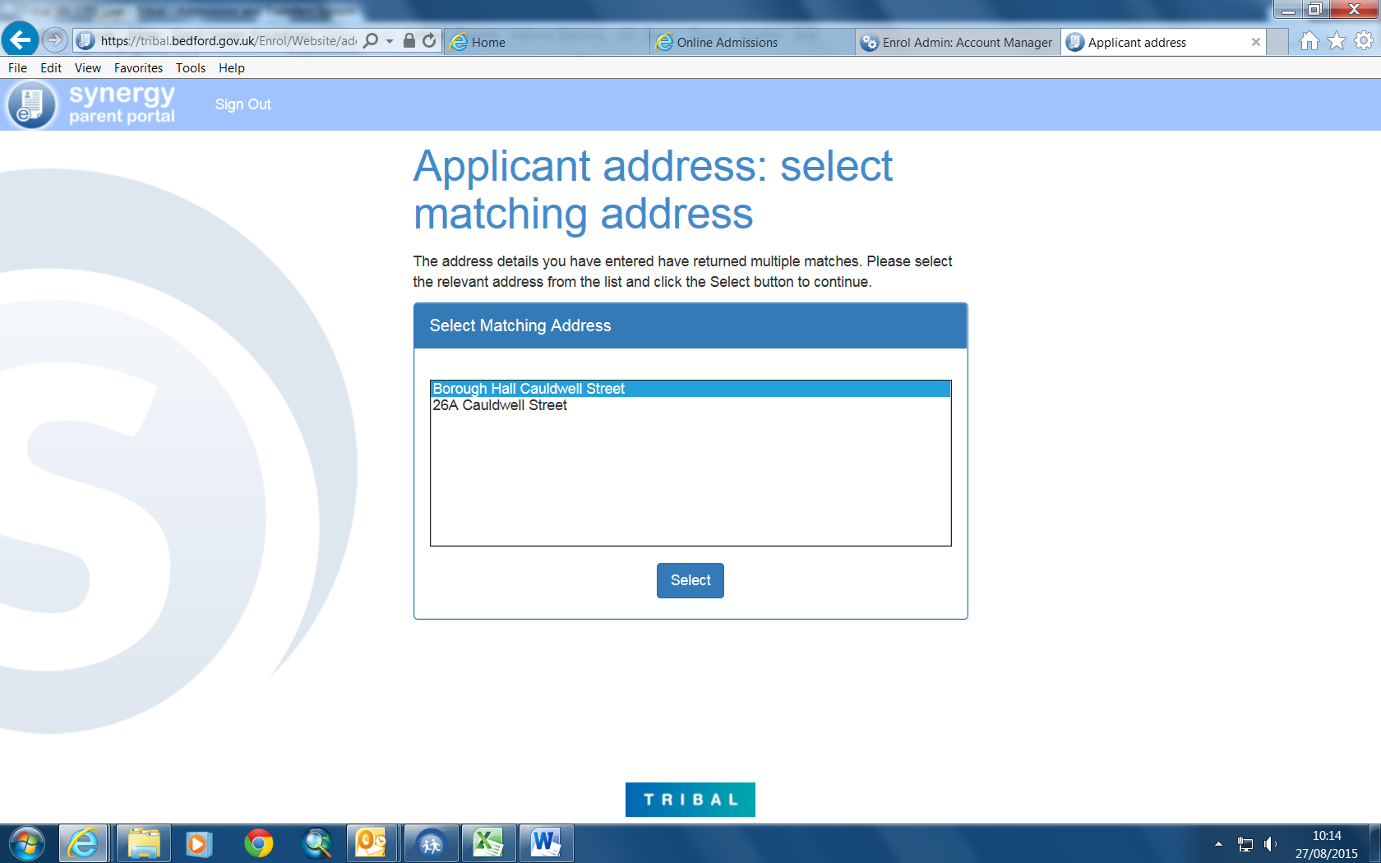
Your address details are copied into the appropriate boxes. Click Next

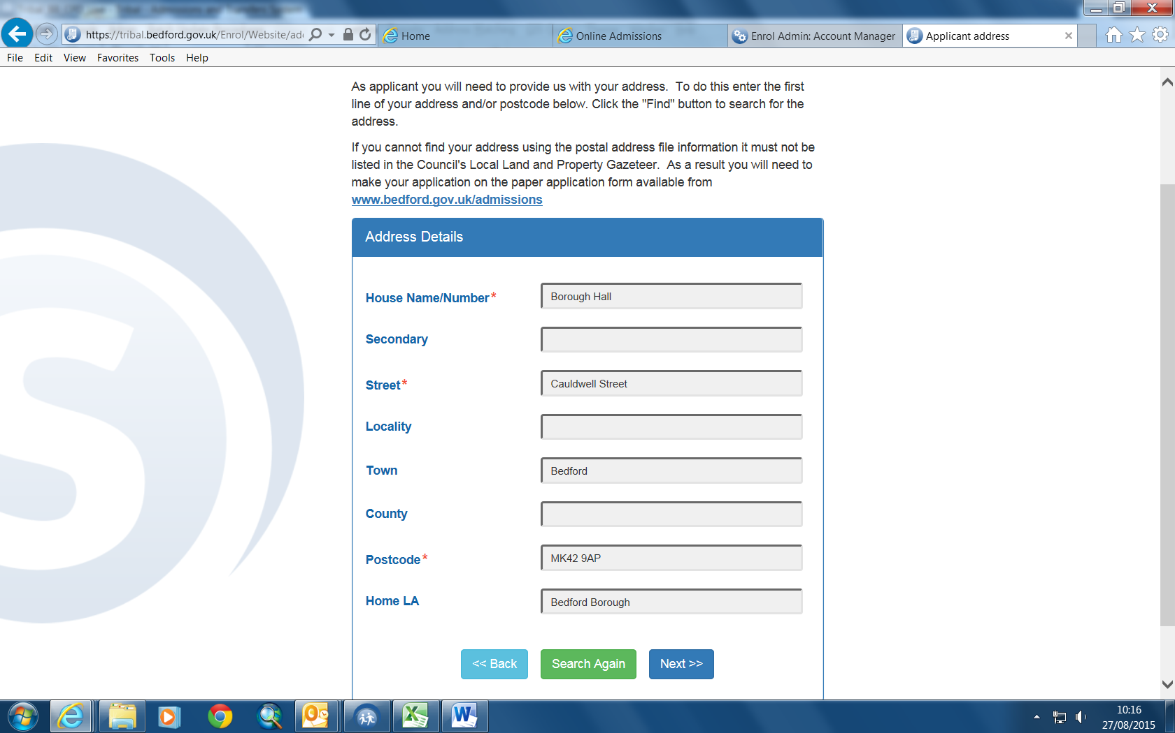

This screen provides a summary of your information as the applicant. Click Confirm

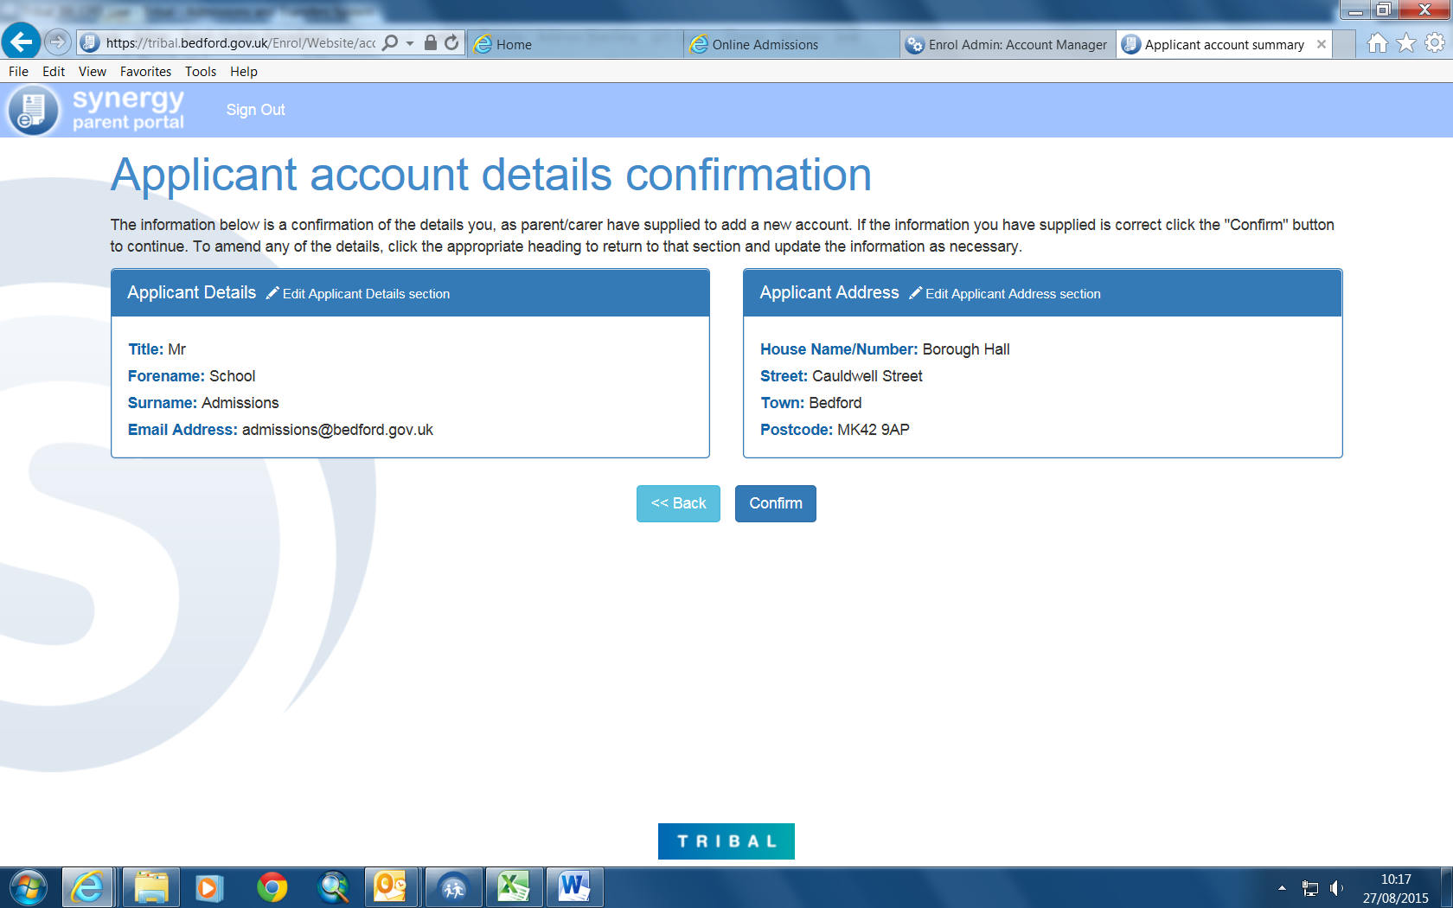

An email will be sent to the email account that has been registered and you will not be able to use the system until the account is verified.

You will get this screen. You should exit the system and open the email from enrol@bedford.gov.uk

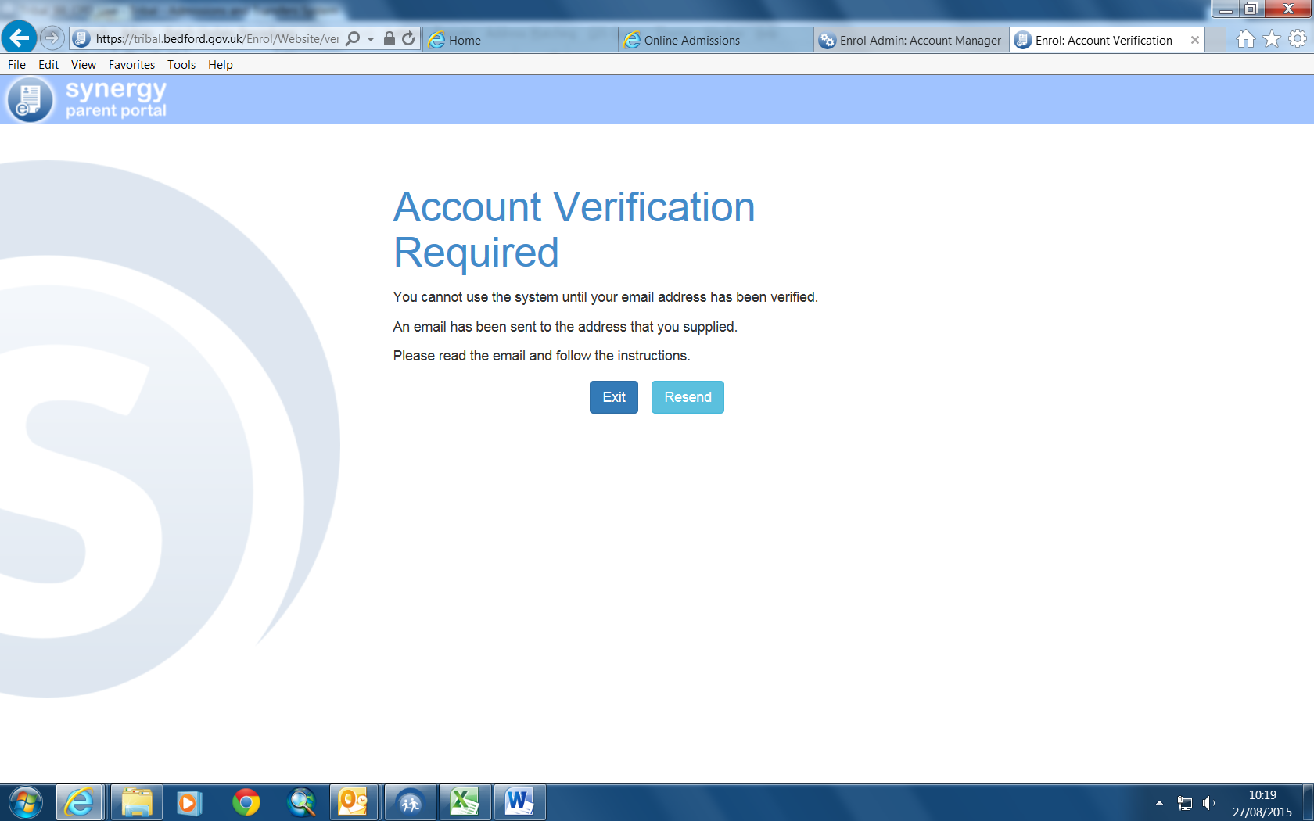

This is an example of the email:

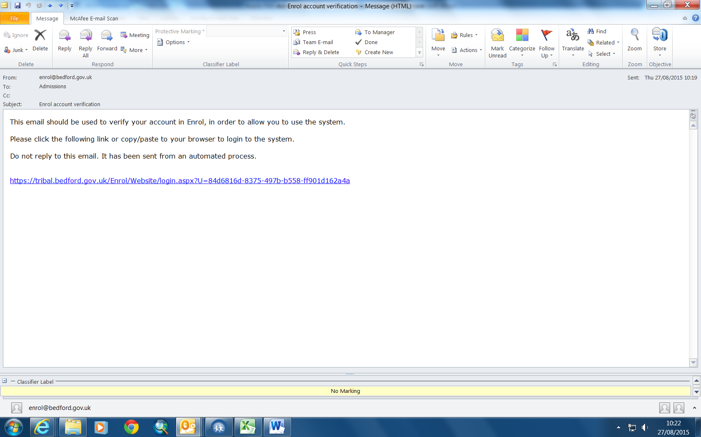

You will need to click on the link

Once you click on the Link it will take you to this screen:

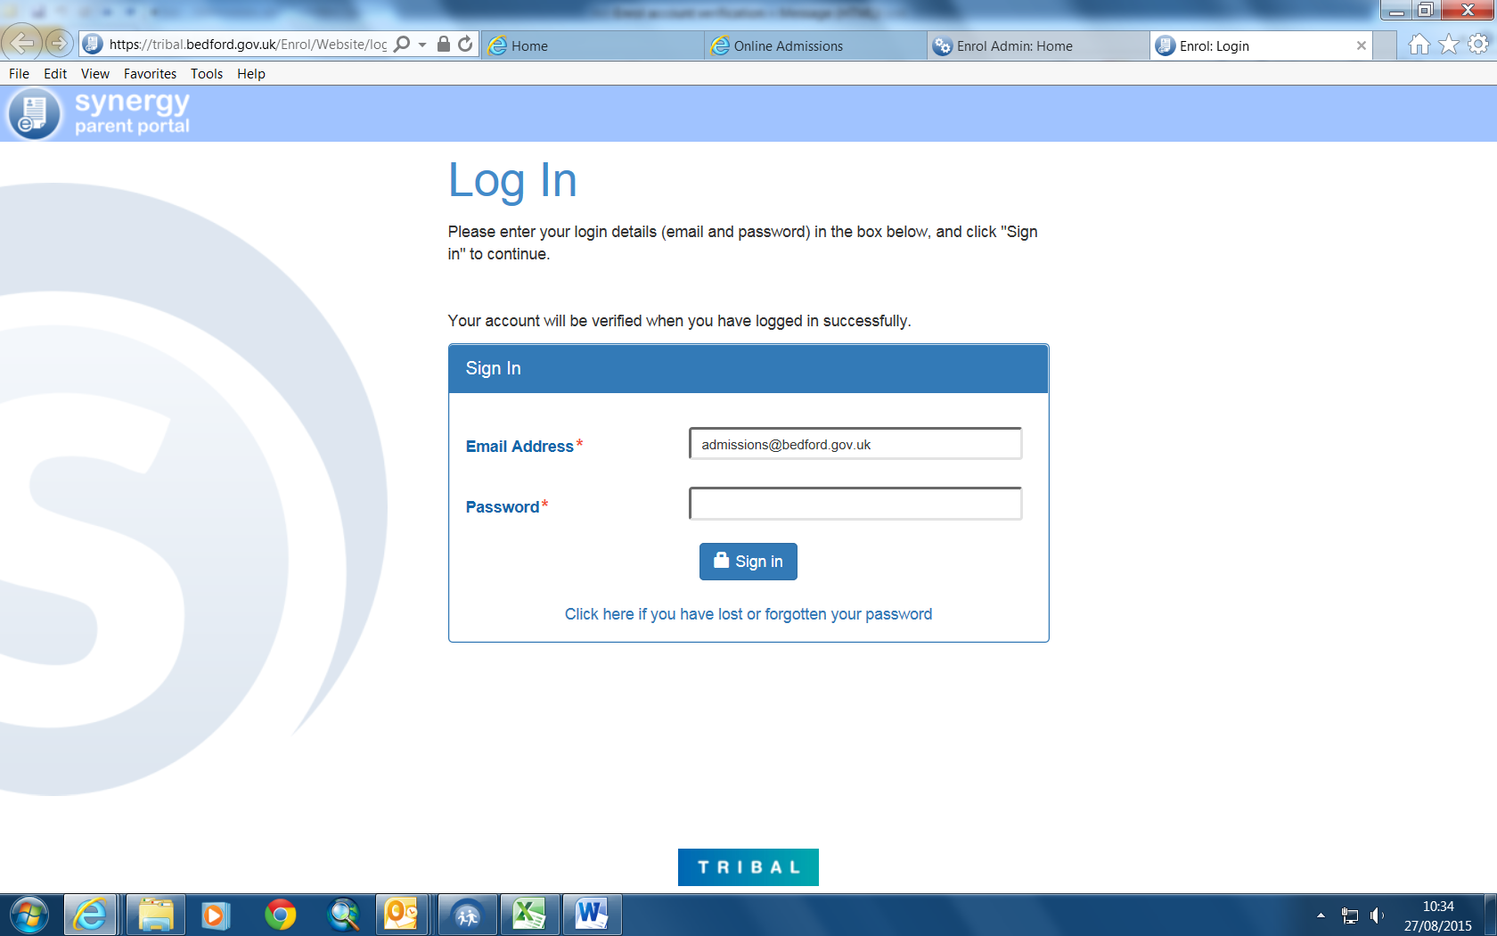

You need to log in with your email address and your password

Then click Sign In.

There is an option to “Click here if you have lost or forgotten your password”.

Once you have signed in this screen will come up:

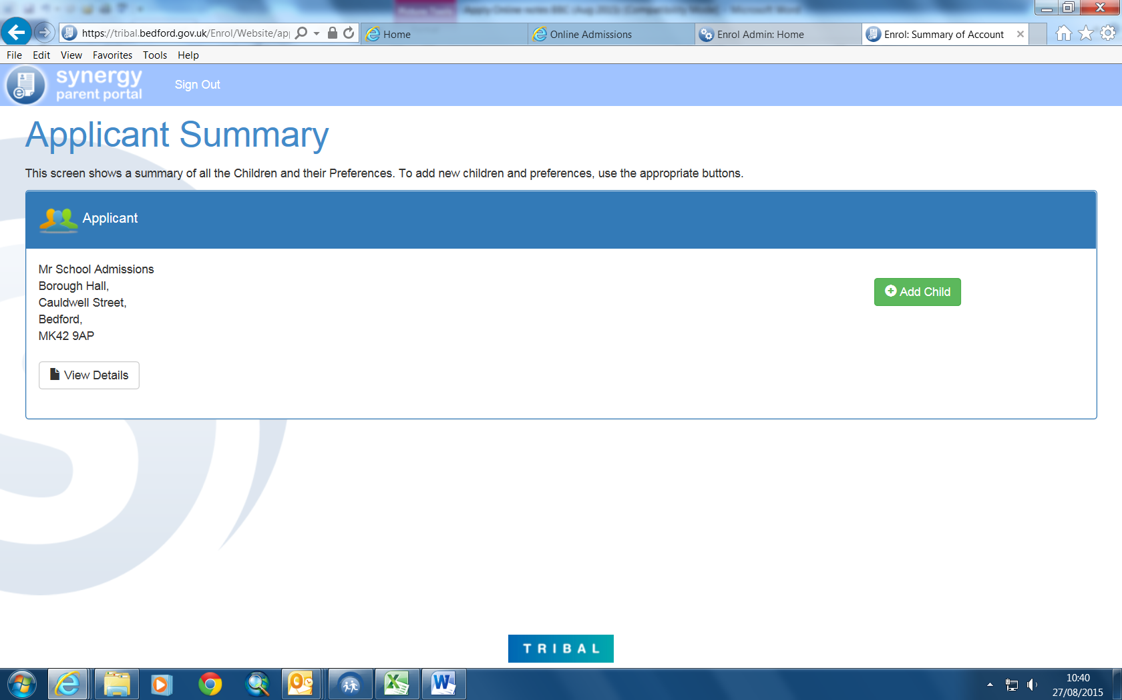

To add details of your Child

Click the “Add Child” link

This screen will appear which allows you to enter your child’s details including their current school.

The current schools are accessed using the drop down arrow. The system will only list the schools recorded on the system for the Local Authority (LA) you have chosen. The system defaults to Bedford Borough but you can select other Councils.

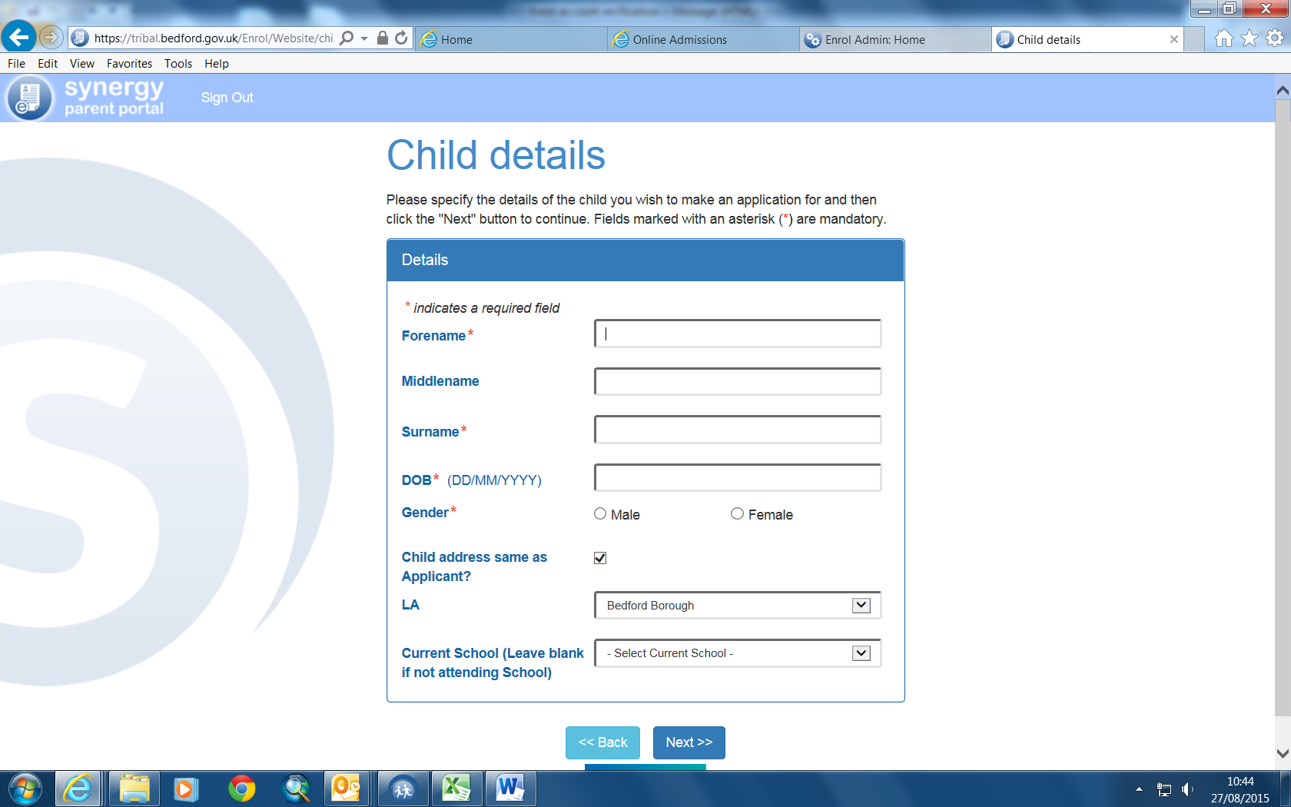

Enter details:

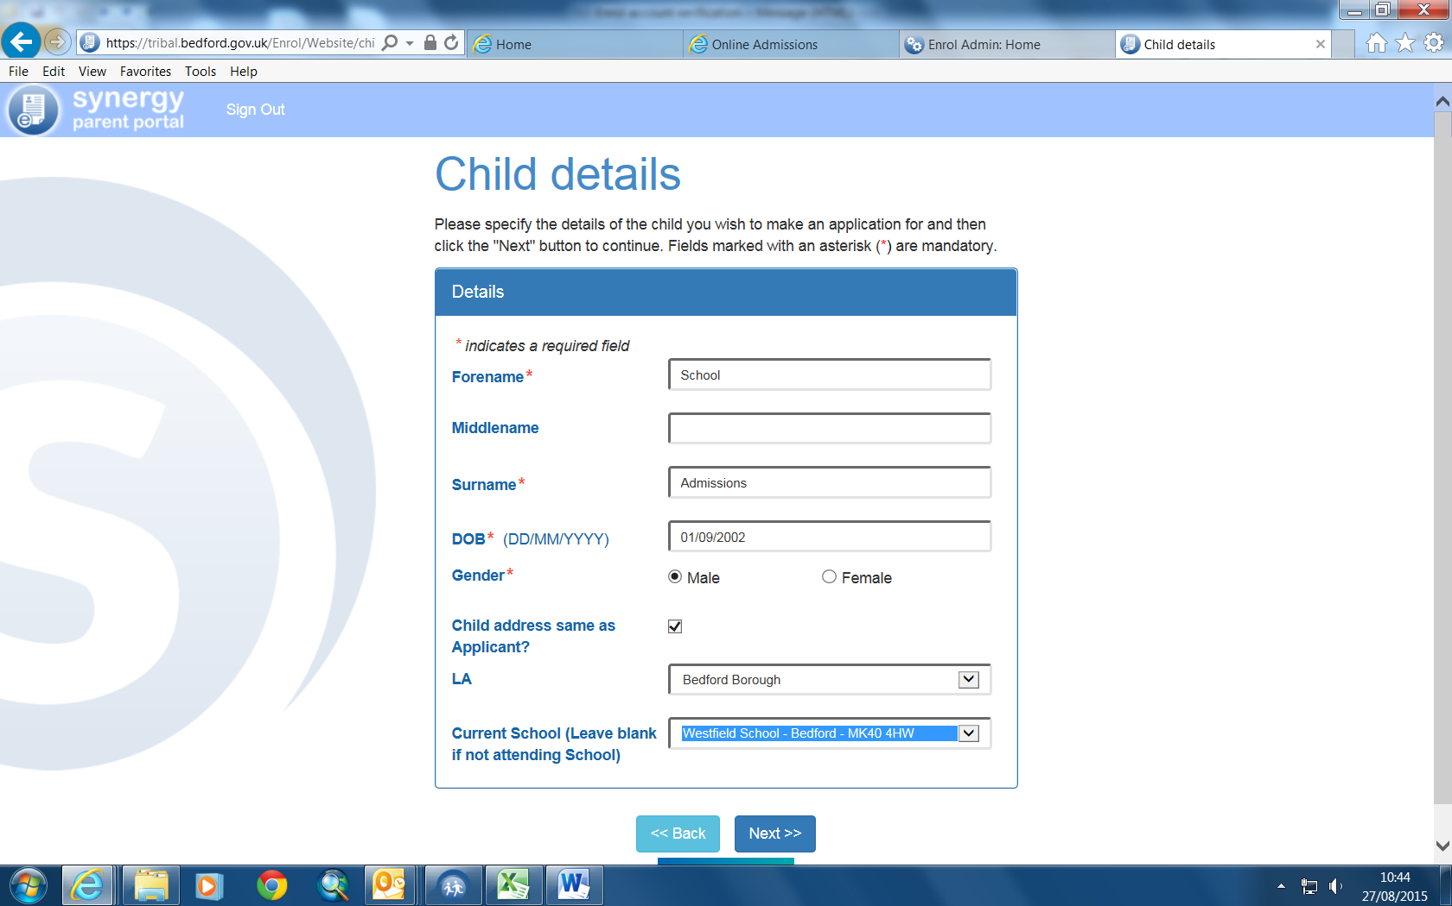

Click Next

You will then have a summary screen.

You can either amend the details using the editing facility or confirm.

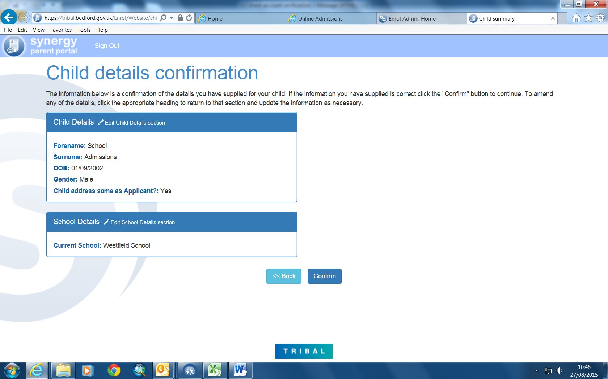
This is the next screen. It is a summary of your details as application and confirms the names of any children that you have set up on the system.

To go to the next stage click the green Apply for School Admissions button

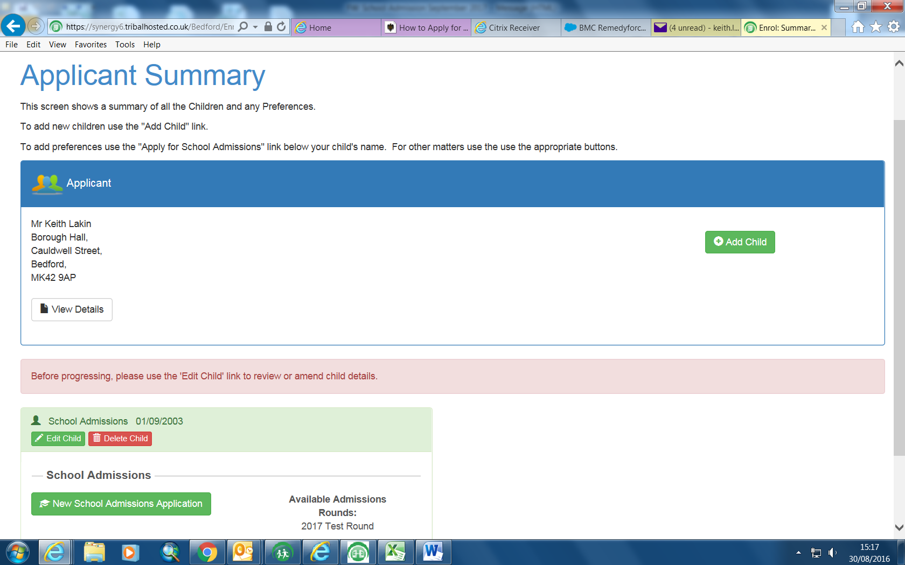

This screen confirms the details for the round that is applicable to your child’s date of birth.

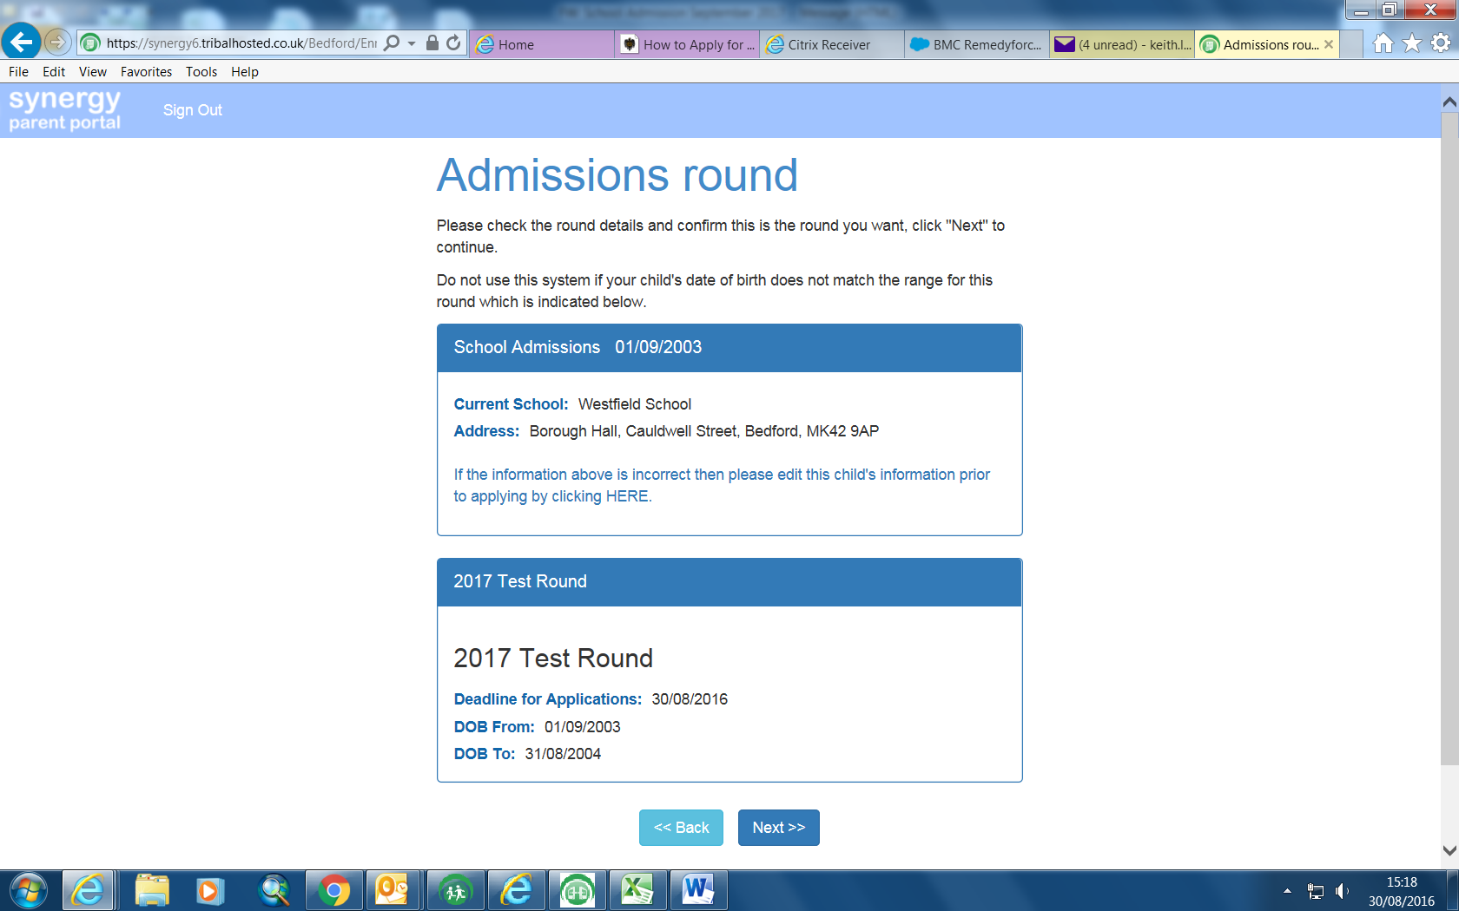

Click on Next
This is the Child Further Details screen

Choose your relationship to the Child

Is your child looked after (In care of a Local Authority)

Does your child have a statement of special educational needs?

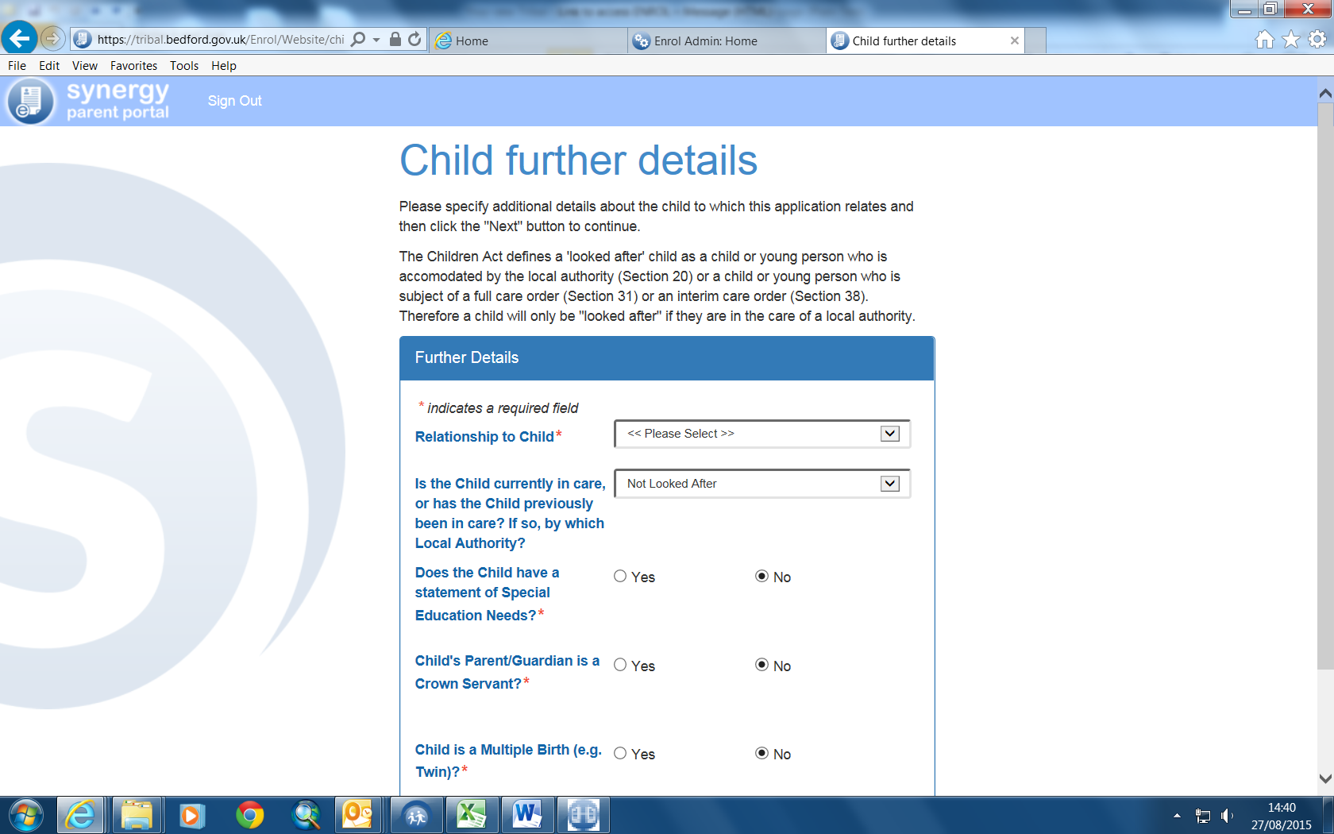

Then click Next

This screen allows you to check the details that you have recorded for your child.

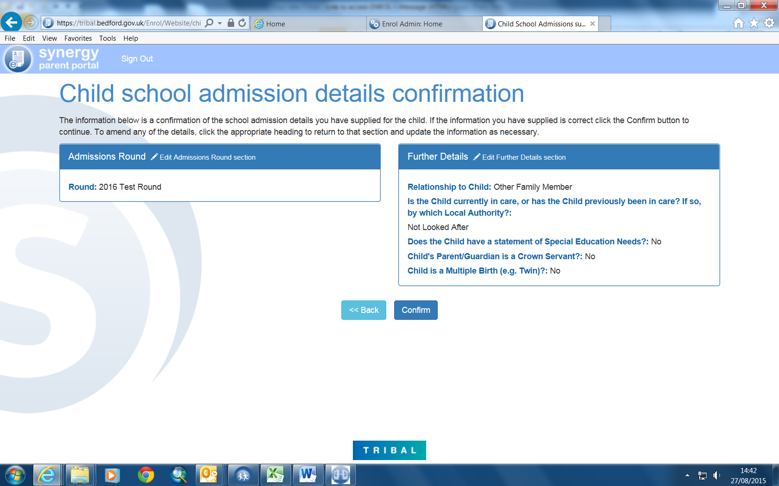

Click on Confirm

You are now ready to select the school(s) that you would like your child to attend

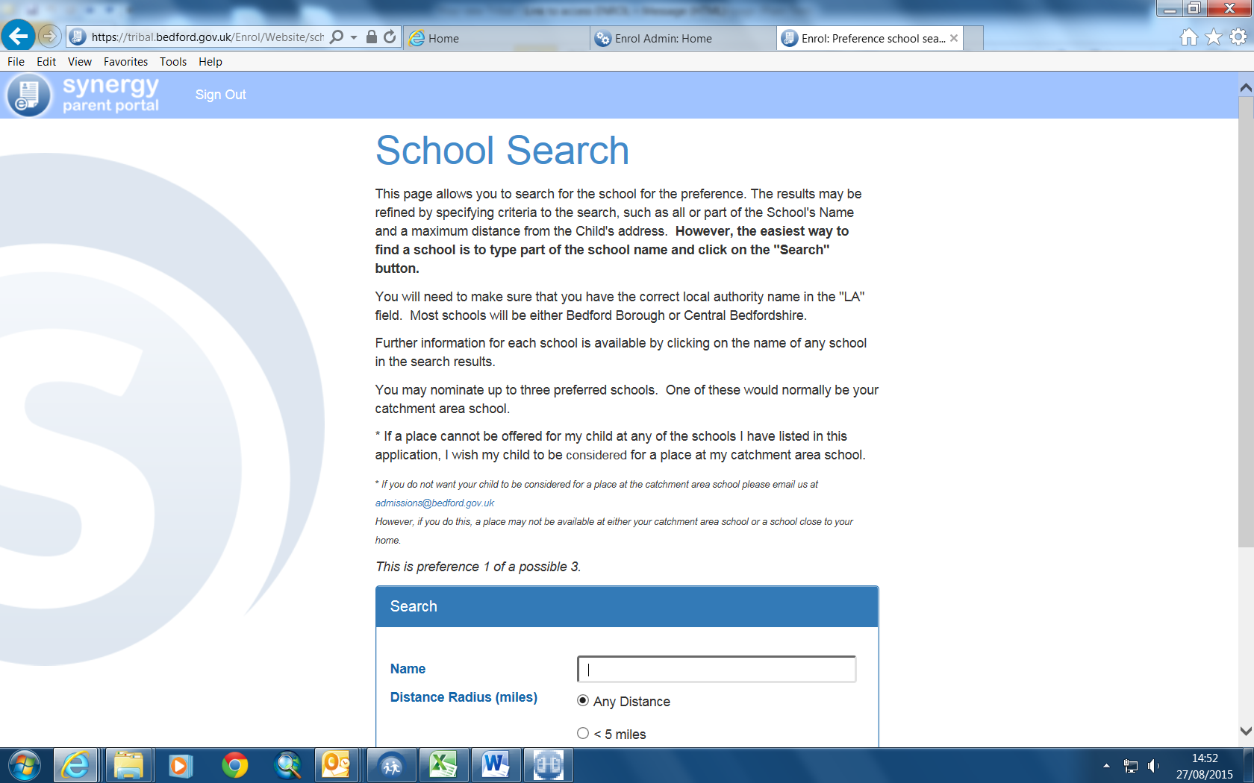

You will need to make sure that the correct LA is in the box

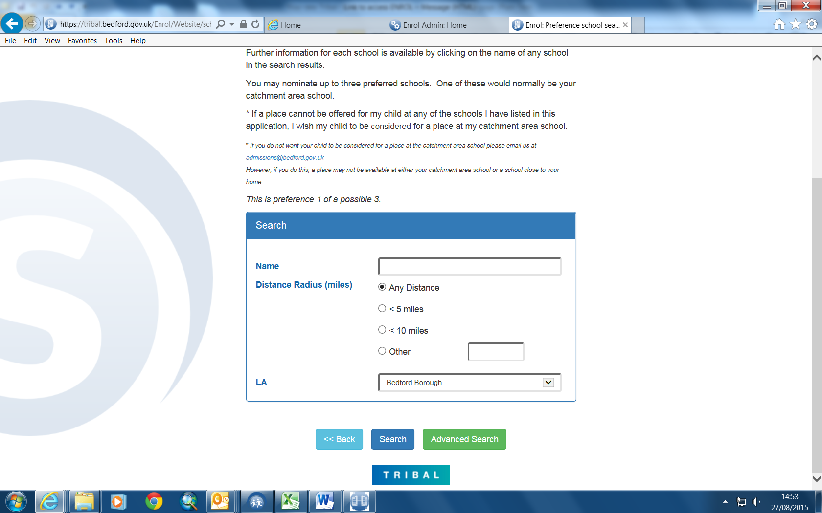

Click on Search to see the schools available.

To select a school Click on Select

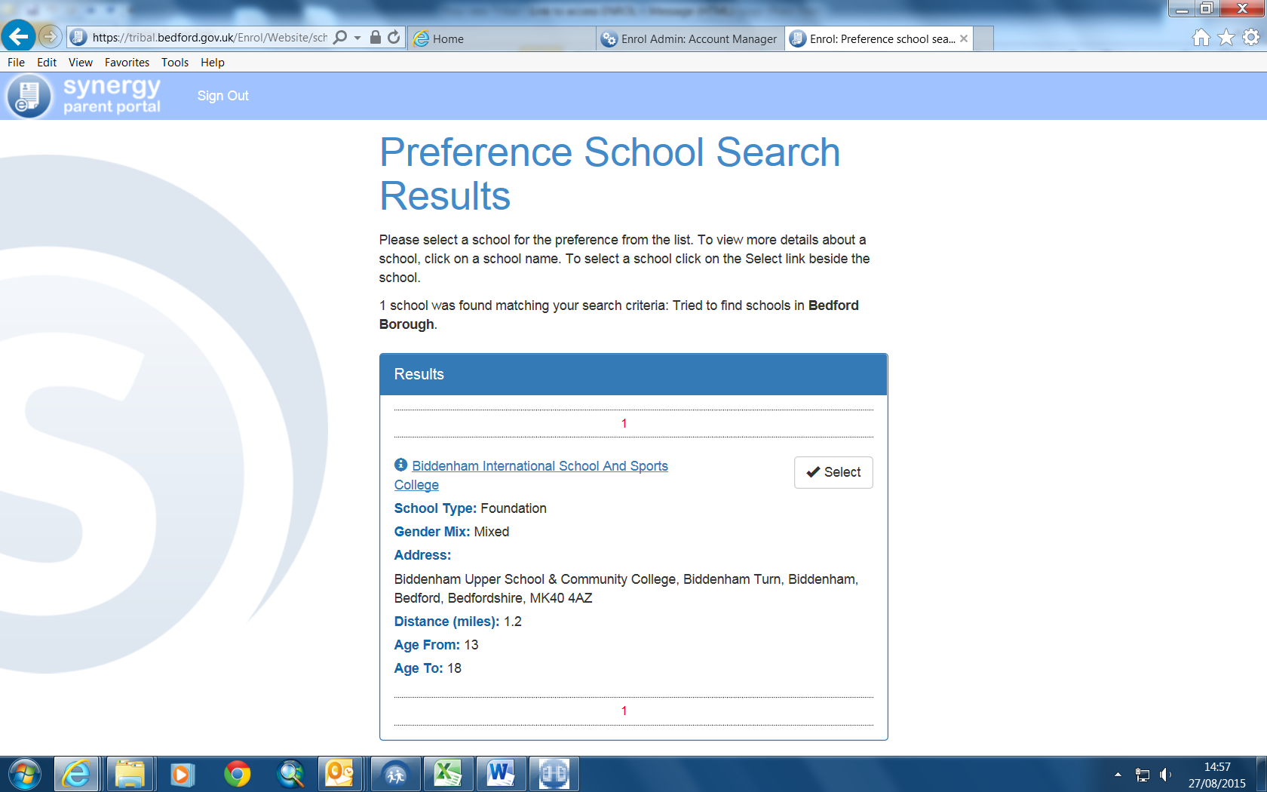

This Screen will enable you to indicate the reason for applying. It is called a Preference Reason:

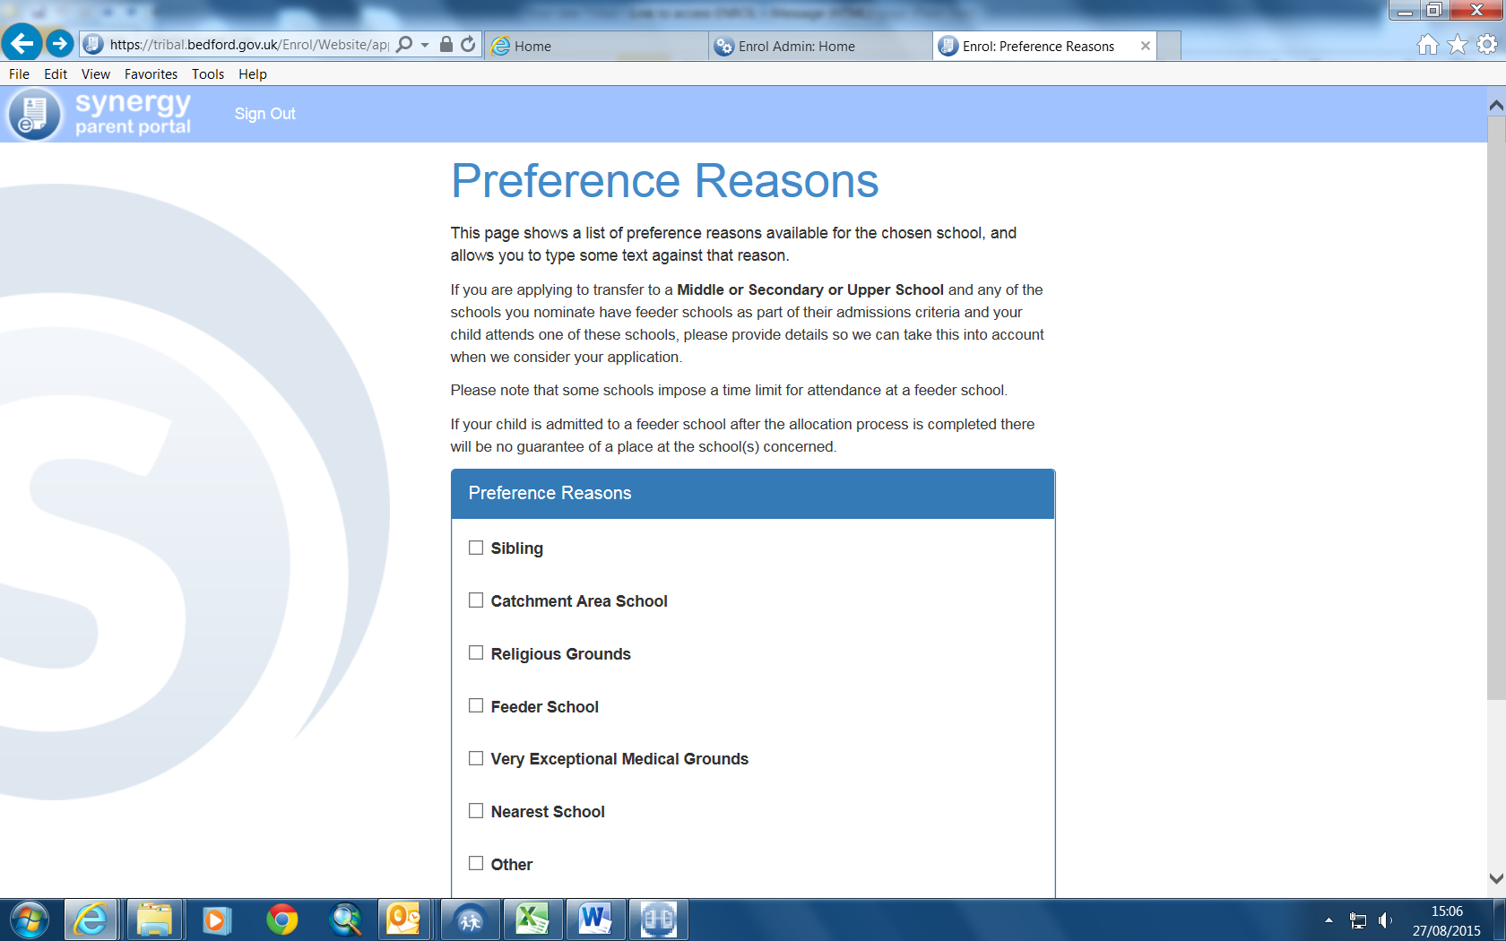

Then click Next

Preference school details confirmation page will appear:

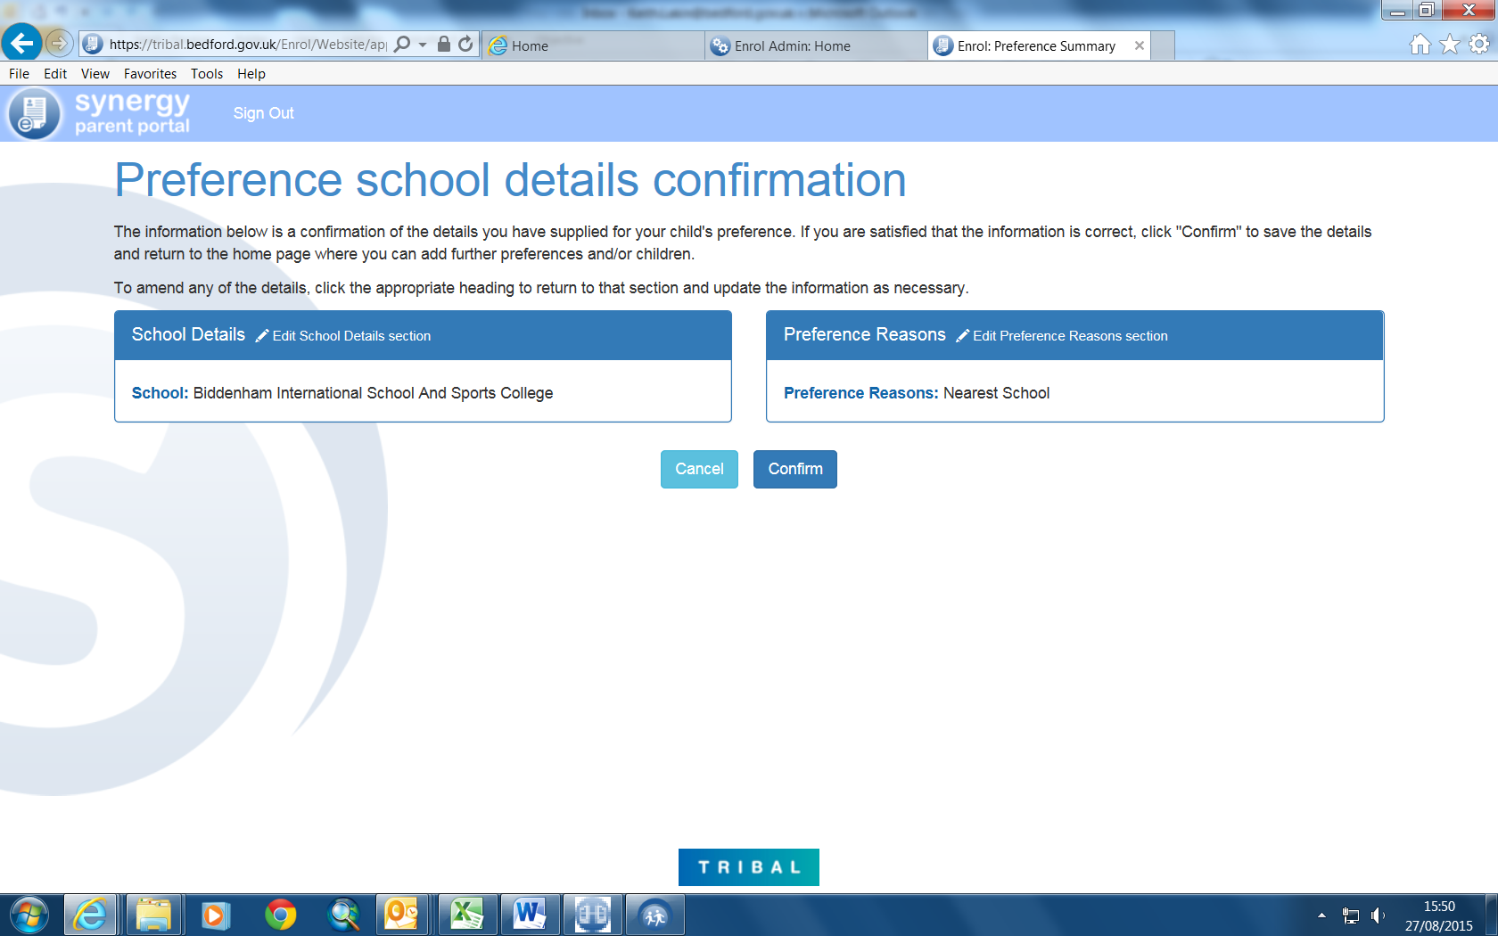

Click Confirm

You will be asked “Do you want to add another Preference?” Choose Yes or No.

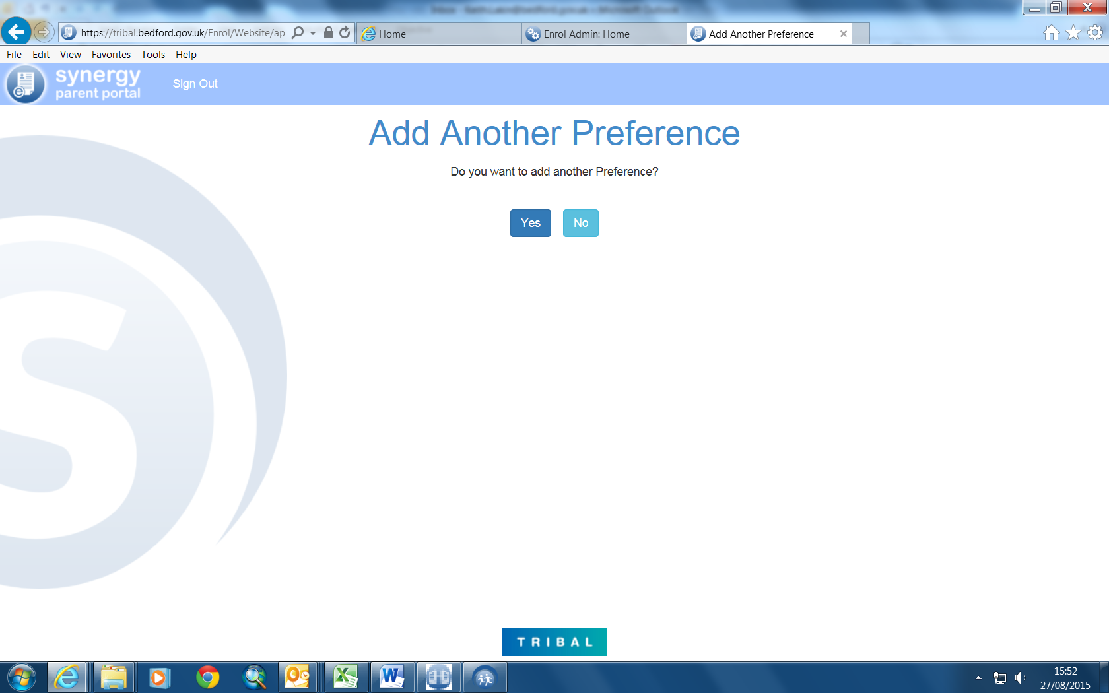

If you Click Yes, you will be able to add more preferences following the same process as detailed above.

If click No then this screen will appear

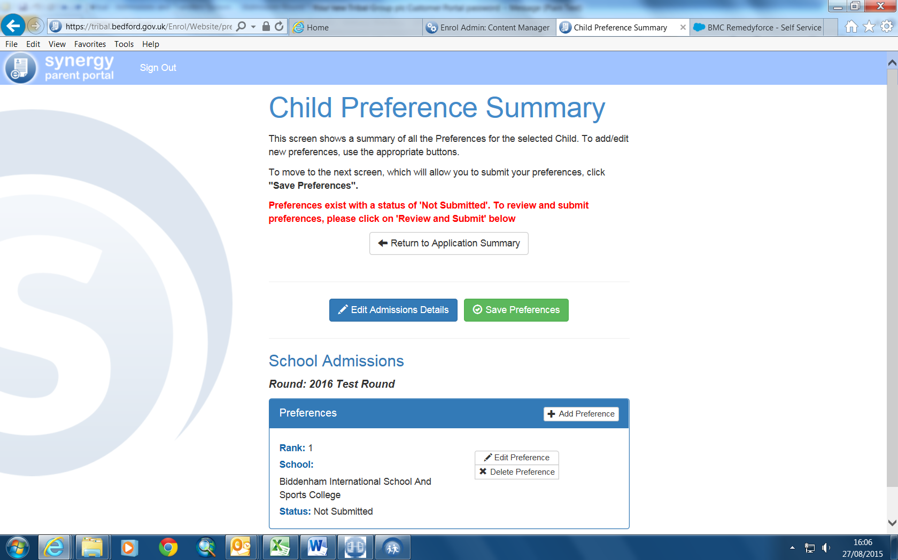

To submit preferences click on ‘Save preferences’
This screen will appear which includes a summary of your details as the applicant, your child’s details and the preference(s) details.

You need to click Submit application:

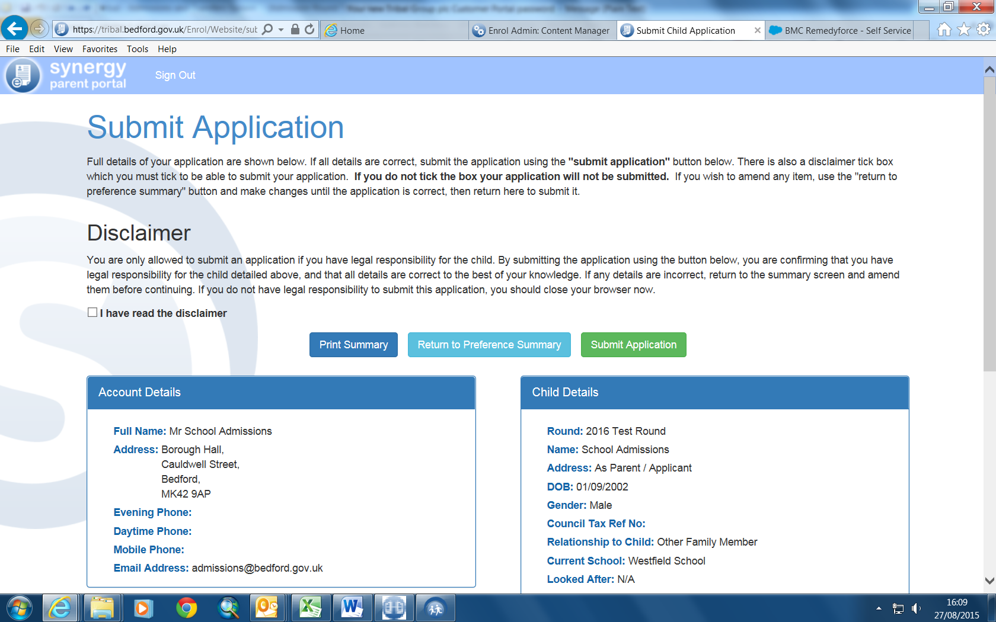

If you do not tick the Disclaimer you will get this screen- and need to tick the disclaimer

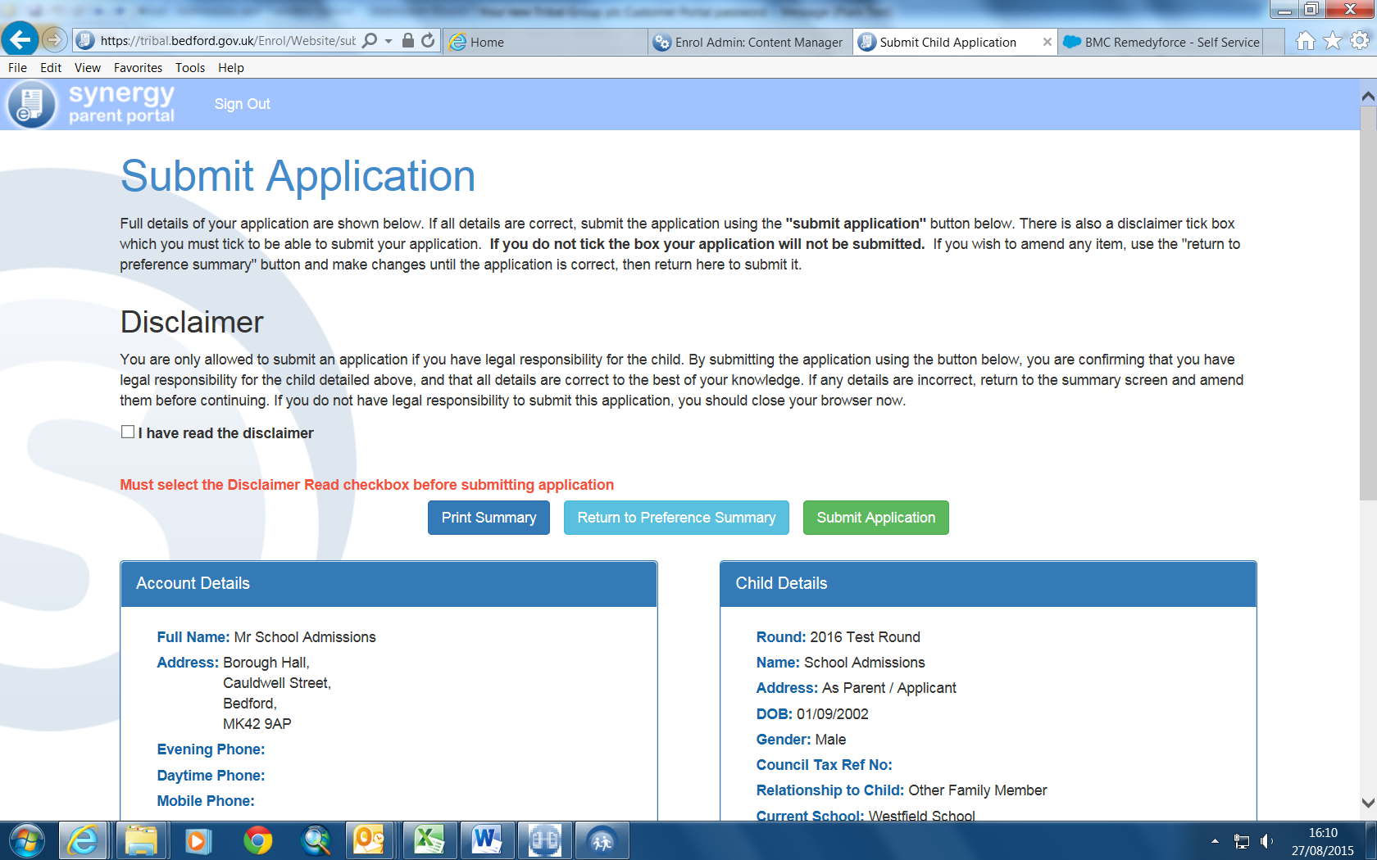

Then press Submit Application

This screen will appear:

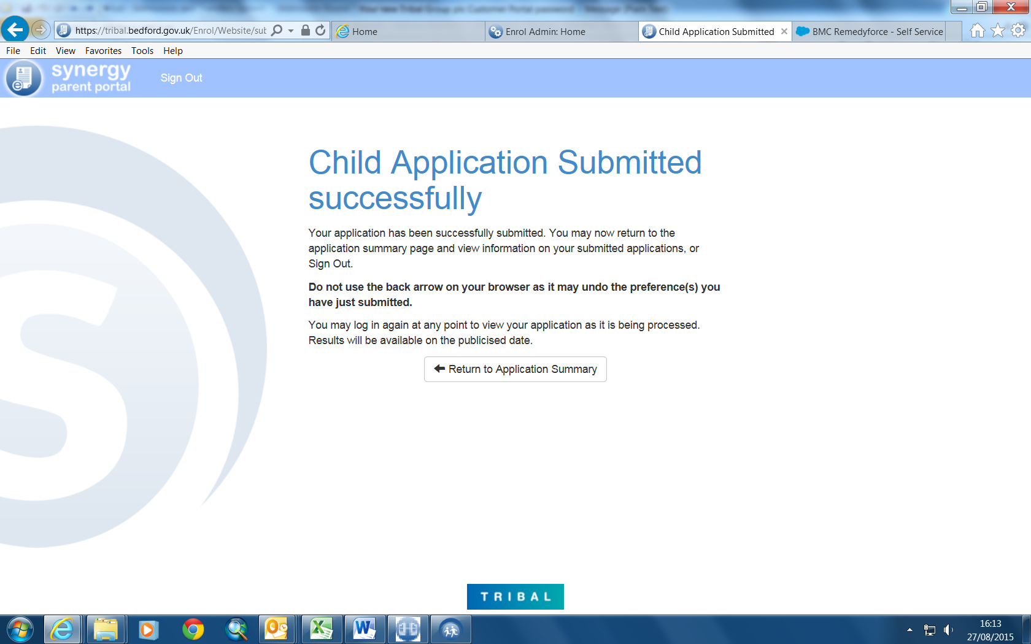

Then make sure you click on the Logout button

Do not use the back arrow on your browser as it may undo the preference(s) you have just submitted.

You will then receive email from enrol@bedford.gov.uk that looks like this:

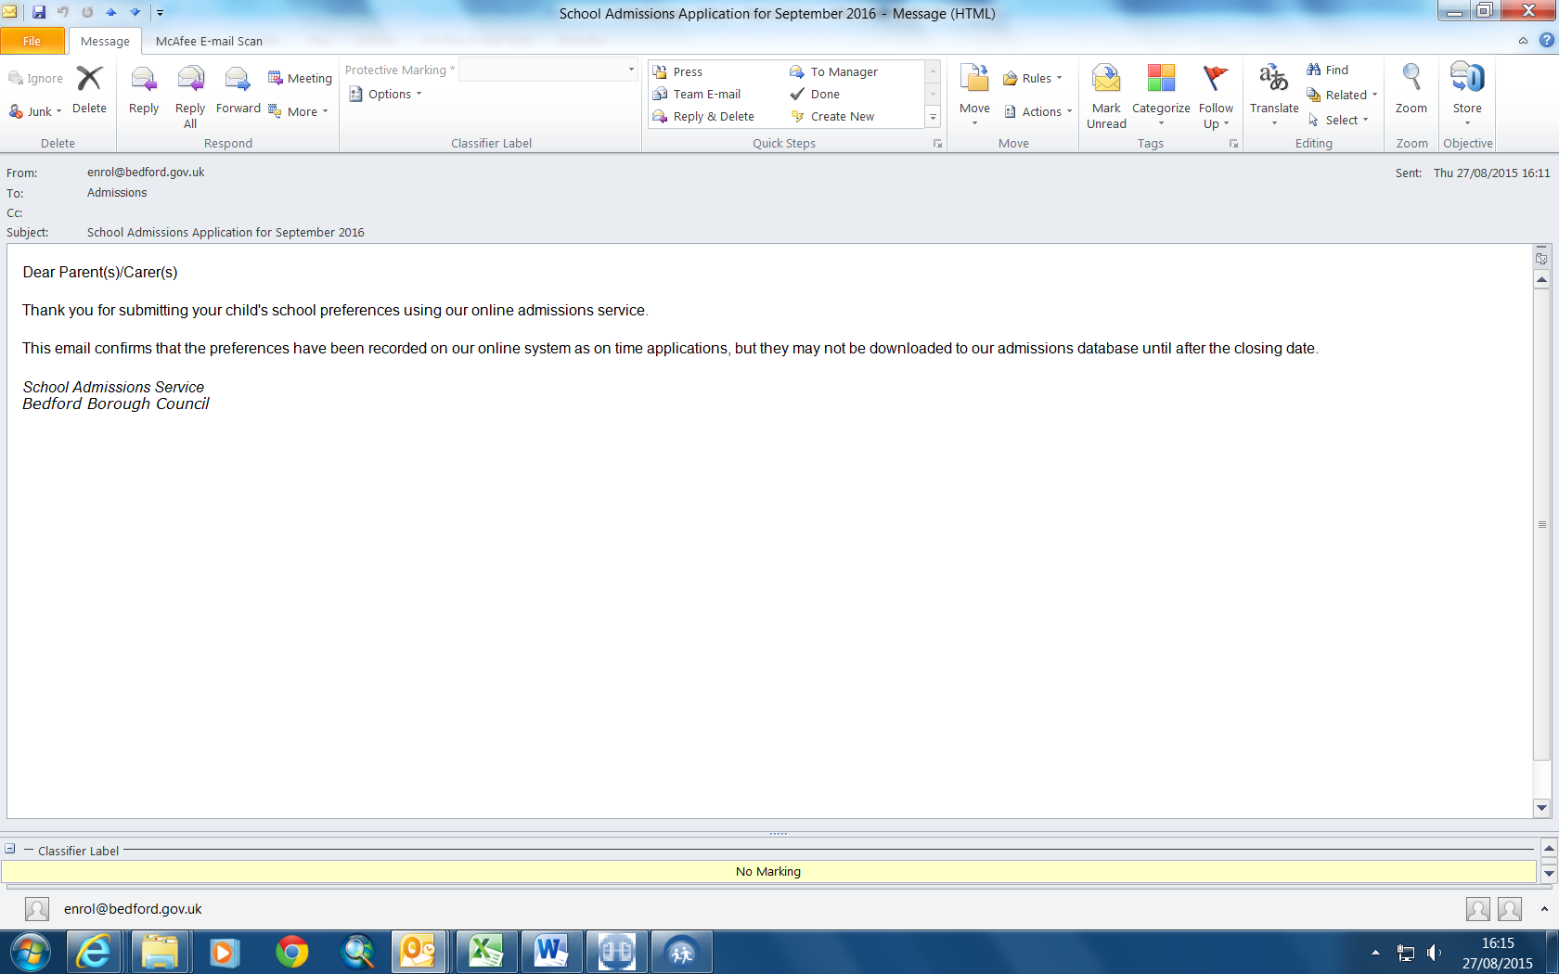

/tmp/lo/0000.doc

